**ARDUINO BASED SMART HOME HUB**

SYED ADZHA MUHAYMIN BIN SYED MUHAMMAD

CHIANG KARH LORH

NURUL ATIKAH BINTI OSLAN

HASSANKAFI ABDULLAHI ADED

SITI NURHALIZA BINTI RAMLI

**SCHOOL OF COMPUER AND**

**COMMUNICATION ENGINEERING**

**UNIVERSITI MALAYSIA PERLIS**

**2019**

**ARDUINO BASED SMART HOME HUB**

**by**

|  |  |
| --- | --- |
| **NAME** | **MATRIC NO** |
| SYED ADZHA MUHAYMIN BIN SYED SYED MUHAMMAD | 161231463 |
| CHIANG KARH LORH | 161020815 |
| NURUL ATIKAH BINTI OSLAN | 151081461 |
| HASSANKAFI ABDULLAHI ADED | 161080019-1 |
| SITI NURHALIZA BINTI RAMLI | 161020873 |

**A report submitted**

**In fulfillment of the requirement for the degree of**

**Bachelor of Engineering (Honors)**

**Communication Engineering**



**School of Computer and Communication Engineering**

**Universiti Malaysia Perlis**

**May 2019**

**ACKNOWLEDGMENT**

First and foremost, we would like thank Universiti Malaysia Perlis (UniMAP) and the School of Computer and Communication Engineering (SCCE) for teaching us the correct and necessary content to practice the knowledge we had benefited and gained through our years of studying here this will surely help in our real-life experiences.

Besides that, the greatest gratitude goes to our supervisors Dr. Naimah Yaakob and Dr. Mohamed Elshaikh Elobaid for the valuable guidance and advice until the day of finishing this project. Under their supervision, we are able to solve the problems occurred when carried out this project and at the same time we gained a lot of precious knowledge.

Furthermore, many thanks go to all team members for the great teamwork in finishing this project until the end. Last but not least, many thanks go to those who have helped us out with their abilities directly and indirectly in completing this project.

**APPROVAL AND DECLARATION SHEET**

This project titled Arduino based Smart Home Hubusing Arduino was prepared and submitted by SYED ADZHA MUHAYMIN BIN SYED MUHAMMAD (161231463), CHIANG KARH LORH (161020815), NURUR ATIKAH BINTI OSLAN (151081461), HASSANKAFI ABDULLAHI ADED (161080019-1), SITI NURHALIZA BINTI RAMLI (161020873) have been found satisfactory in term of scope, quality and presentation as partial fulfilment of the requirement for the Bachelor of Engineering (Computer Engineering, Communication Engineering and Computer Network Engineering) in Universiti Malaysia Perlis (UniMap)

**Checked and Approved by**

**(DR. NAIMAH YAKOB) (DR. MOHAMED ELSHAIKH ELOBAID)**

**Project Supervisor**

**School of Computer and Communication Engineering**

**Universiti Malaysia Perlis**

**May 2019**

**ABSTRACT**

The increasing number of home intruder nowadays is one of the reasons why this project is built. This project is also built to monitor several unexpected conditions that might happen in a house such as gas leaking and fire in kitchen that could be harmful to the household. The user can also monitor the temperature in the house to ensure comfortability. In this project, a low cost and flexible smart home control and monitoring system using an embedded micro-web server is proposed. This project includes IP connectivity for accessing and controlling devices and appliances remotely using Arduino based and the website. The proposed method offers a communication protocol to monitor and control the home environment with more than just the switching functionality. This is to provide a convenient, yet a secure home automation system. The system is portable and built in a way that the user can easily install, control and run the sensor in the house. The system will detect the movement of unauthorized guest, gas leaking and fire in the house. The data from the several sensors are then sent to the website using the Wi-Fi module. When movement is detected, the camera then sends the picture to the website. Arduino Mega (ATmega2560) and Arduino Uno (ATmega328P) are used as the microcontroller where the program is developed by Arduino.cc. NodeMCU, which is an open source IoT platform is used as a WIFI Module while camera OV7670 is used to capture unauthorized movement in the house.

**ABSTRAK**

Kadar jenayah pecah rumah yang meningkat adalah salah satu factor utama kenapa projek ini dijalankan. Projek ini juga dibangunkan untuk memantau beberapa kejadian yang tidak diingini yang mungkin berlaku seperti kebocoran gas dan kebakaran di dapur yang boleh membahayakan seisi rumah. Pengguna juga boleh memantau suhu di dalam rumah untuk memastikan keselesaan. Dalam projek ini, sistem kawalan dan pemantauan rumah pintar dengan menggunakan pelayan web mikro tertanam yang fleksibel dan berkos rendah dicadangkan. Projek ini juga termasuk dengan sambungan IP untuk mengakses dan mengawal peranti dan peralatan dari jauh mengunakan asas Arduino dan laman web. Cadangan kaedah menawarkan protokol komunikasi untuk memantau dan mengawal persekitaran rumah lebih dari hanya fungsi suis. Ini akan menyediakan sistem automasi rumah yang mudah, namun selamat. Sistem ini adalah system yand mudah alih dan dibina supaya pengguna senang untuk memasang,menawal dan jalankan sensor di dalam rumah. Sistem akan mengesan tetamu yang tidak diundang, kebocoran gas dan kebakaran. Data daripada beberapa sensor dihantarkan ke laman web menggunakan modul Wi-Fi. Apabila pergerakan dikesan, kamera kemudian akan menghantar gambar ke laman web. Mikropengawal yang digunakan adalah Arduino Mega (ATmega2560) and Arduino Uno (ATmega328P) dimana programnya dibangunkan dengan menggunakan Arduino.cc. NodeMCU,dimana menggunakan platform IoT dengan sumber terbuka digunakan sebagai modul wifi sementara itu kamera OV7670 digunakan untuk menangkap pergerakan tanpa izin di dalam rumah.

**TABLE OF CONTENTS**

|  |  |
| --- | --- |
| ACKNOWLEDGEMENT | i |
| APPROVAL AND DECLARATION SHEET | ii |
| ABSTRAK | iii |
| ABSTRACT | iv |
| TABLE CONTENTS | v |
| LIST OF FIGURES | viii |
| LIST OF TABLES | x |
| LIST OF ABBREVIATIONS | xi |
| Chapter 1 |  |
| INTRODUCTION | 1 |
| 1.0 Project Background | 1 |
| 1.1 Problem Statement | 2 |
| 1.2 Objectives | 3 |
| 1.3 Scope of Project | 3 |
| Chapter 2 |  |
| METHODOLOGY | 4 |
| 2.0 Introduction | 4 |
| 2.1 Overall Design Structure | 5 |
| 2.2 Design Flow and Process | 6 |
| 2.3 Design Complexity | 10 |
| 2.3.1 Block Diagram | 10 |
| 2.3.2 Schematic Diagram | 11 |
| 2.3.3 Technical Concept | 12 |
| 2.4 Hardware Architecture | 18 |
| 2.4.1 Arduino Mega | 18 |
| 2.4.2 Arduino Uno | 20 |
| 2.4.3 Liquid Crystal Display (LCD) | 22 |
| 2.4.4 NodeMCU | 23 |
| 2.4.5 InfraRed Sensor Module | 25 |
| 2.4.6 Flame Sensor Module | 26 |
| 2.4.7 LDR sensor Module | 27 |
| 2.4.8 Thermistor Sensor Module | 28 |
| 2.4.9 MQ-2 Gas Sensor Module | 30 |
| 2.4.10 Camera ov7670 | 31 |
| 2.4.11 DC Fan | 33 |
| 2.4.12 12V Relay | 34 |
| 2.4.13 Light Emitting Diode (LED) | 35 |
| 2.4.14 Alarm Unit | 35 |
| 2.5 Software Architecture | 36 |
| 2.5.1 Arduino IDE | 25 |
| 2.5.2 Serial Port Reader | 37 |
| Summary | 37 |
| Chapter 3 |  |
| RESULTS AND DISCUSSIONS | 38 |
| 3.0 Results | 38 |
| 3.1 Camera Surveillance System in Living Room | 39 |
| 3.2 Temperature control in Bedroom 1 | 41 |
| 3.3 Light Control in Bedroom 2 | 42 |
| 3.4 Smoke and Flame Detection in Kitchen | 43 |
| 3.5 Smart House Monitoring in the Website | 44 |
| 3.6 Discussion | 50 |
| Chapter 4 |  |
| PROJECT DESIGN AND CONSIDERATION |  |
| 4.1 Health and Safety | 51 |
| 4.2 Environmental Consideration | 52 |
| 4.3 Cultural and Benefits to Society | 52 |
| Chapter 5 |  |
| PROJECT MANAGEMENT AND COSTING | 53 |
| 5.0 Project Gantt Chart | 53 |
| 5.1 Task Allocation | 54 |
| 5.2 Project Costing | 56 |
| Chapter 6 |  |
| CONCLUSION AND RECOMMENDATION | 57 |
| 6.0 Summary | 57 |
| 6.1 Recommendation | 58 |
| REFRENCES | 59 |
| APPENDICES | 60 |

**LIST OF FIGURES**

|  |  |
| --- | --- |
| Figure 1.0: Smart home |  |
| Figure 2.0: Overall System Overview of Smart Home |  |
| Figure 2.1: Flowchart of thermistor sensor and LDR sensor part |  |
| Figure 2.2: Flowchart of IR sensor (window and living room) part |  |
| Figure 2.3: Flowchart of IR sensor (back door and front door) and gas sensor part |  |
| Figure 2.4: Flowchart of flame sensor and camera ov7670 |  |
| Figure 2.5: Block Diagram of the Project |  |
| Figure 2.6: Schematic Diagram of the Project |  |
| Figure 2.7: Coding part of LDR sensor and LED Control |  |
| Figure 2.8: Coding part of Flame sensor |  |
| Figure 2.9: Coding part of IR sensor |  |
| Figure 2.10: Coding part of Smoke sensor |  |
| Figure 2.11: Coding part of Thermistor sensor and Fan Control |  |
| Figure 2.12: Coding part of Camera |  |
| Figure 2.13: Arduino Mega |  |
| Figure 2.14: Arduino Uno |  |
| Figure 2.15: LCD display |  |
| Figure 2.16: NodeMCU |  |
| Figure 2.17: InfraRed Sensor Module |  |
| Figure 2.18: Flame Sensor Module |  |
| Figure 2.19: LDR Sensor Module |  |
| Figure 2.20: Thermistor Sensor Module |  |
| Figure 2.21: MQ-2 Smoke Sensor Module |  |
| Figure 2.22: Arduino Camera OV7670 |  |
| Figure 2.23: DC Fan |  |
| Figure 2.24: 12V Relay |  |
| Figure 2.25: LED light bulb |  |
| Figure 2.26: Buzzer |  |
| Figure 2.27: Program Coding in Arduino IDE |  |
| Figure 2.28: Serial Port Reader |  |
| Figure 3.0: Overall System |  |
| Figure 3.1: No intruder (a) Window (b) Middle of living room (c) Front door  (d) Back door |  |
| Figure 3.2: Intruder Detected (a) Window (b) Middle of living room (c) Front door  (d) Back door |  |
| Figure 3.3: Value of temperature inside room number 1 |  |
| Figure 3.4: Image captured |  |
| Figure 3.5: Fan (a) OFF (b) ON |  |
| Figure 3.6: Webpage control (a) Fan ON (b) Fan OFF |  |
| Figure 3.7: Light (a) ON (b) OFF |  |
| Figure 3.8: Webpage control (a) Light ON (b) Light OFF |  |
| Figure 3.9: Flame sensor (a) No flame detected (b) Flame detected |  |
| Figure 3.10: Gas sensor (a) No gas detected (b) Gas detected |  |
| Figure 3.11: Fan status (a) Fan off (b) Fan on |  |
| Figure 3.12: Temperature sensor detail |  |
| Figure 3.13: Light status (a) Light off (b) Light on |  |
| Figure 3.14: Gas status (a) No gas detected (b) Gas detected |  |
| Figure 3.15: IR sensor status when there no intruder (a) Living room  (b) Front Door (c)Window (d) Back door |  |
| Figure 3.16: IR sensor status when intruder detected (a) Living room  (b) Front Door (c) Window (d) Back door |  |
| Figure 3.17: Flame sensor status (a) No flame detected (b) flame detected |  |

**LIST OF TABLES**

|  |  |
| --- | --- |
| Table 2.1: The Technical Specification of Arduino Mega |  |
| Table 2.2: The Technical Specification of Arduino Uno |  |
| Table 2.3: The Technical Specification of NodeMCU |  |
| Table 2.4: The Technical Specification of IR Sensor Module |  |
| Table 2.5: The Technical Specification of Flame Sensor Module |  |
| Table 2.6: The Technical Specification of LDR Sensor Module |  |
| Table 2.7: The Technical Specification of Thermistor Sensor Module |  |
| Table 2.8: The Technical Specification of MQ-2 Gas Sensor Module |  |
| Table 2.9: The Technical Specification of Arduino Camera OV7670 |  |
| Table 2.10: The Technical Specification of DC Fan |  |
| Table 2.11: The Technical Specification of 12V Relay |  |
| Table 5.0: The Gantt Chart |  |
| Table 5.1: Report Task Allocation  Table 5.2: Project Task Allocation |  |
| Table 5.3: Project Costing |  |

**LIST OF ABBREVIATIONS**

IDE Integrated Development Environment

LCD Liquid Crystal Display

LED Light Emitting Diode

LDR Light Dependent Resistor

IR Infrared

IC Integrated Circuit

GPIO General Purpose Input Output

DC Direct Current

AC Alternating Current

AO Analog Output

DO Digital Output

NTC Negative Temperature Coefficient

CPU Central Processing Unit

PMW Pulse Width Modulation

UART Universal Asynchronous Receiver Transmitter

USB Universal Serial Bus

IoT Internet of Things

**CHAPTER 1**

**INTRODUCTION**

* 1. **Background**

A smart home is a residence that uses internet-connected devices to enable the remote monitoring and management of appliances and systems such as lighting and heating. Smart home technology, also often referred to as home automation or domotics (from the Latin "domus" meaning home), provides homeowners with security, comfort, convenience and energy efficiency by allowing them to control smart devices, often by a smart home app on their smartphone or other networked device [1]. One of the examples is Arduino-based smart home hub which allows home residence to control the devices remotely from outside of the house and monitor home environment via smart phone as shown in Figure 1.1.

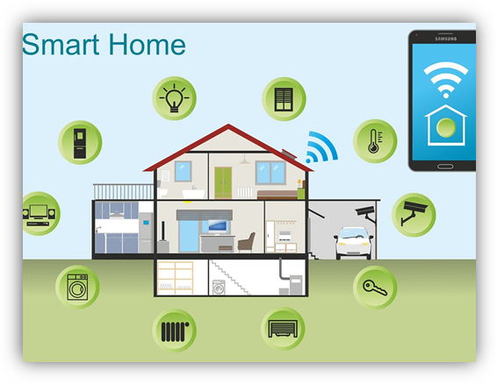

**Figure 1.1:** Arduino-basedSmart Home Hub.

According to the Doctor of Arts in Writing, Jackie Craven, in 2019 alone, a smart home is a home that has highly advanced, automated systems to control and monitor any function of a house such as lighting, temperature control, multi-media, security, window and door operations, air quality, or any other task of necessity or comfort performed by a home's resident. With the rise of wireless computerization, remote-controlled devices are becoming smart just-in-time. Today, it is possible to pin a programmed chip onto any occupant and have systems adjusted accordingly as a person passes by through a smart home [2]. A smart home appears "intelligent" because its computer systems can monitor so many aspects of daily living.

Smart house can be controlled via a microcontroller such as Arduino or Raspberry Pie. The Arduino has also been used in thousands of different projects and applications. Arduino refers to an open-source platform used for building electronics projects. Arduino consists of both a physical programmable circuit board (often referred to as a [micro-controller](http://en.wikipedia.org/wiki/Microcontroller)) and a piece of [software](http://arduino.cc/en/Main/Software), or IDE (Integrated Development Environment) that runs on the computer, used to write and upload computer code to the physical board. The Arduino platform has become quite popular with people just starting out with electronics and for good reason. The use of Arduino in smart home hubs can help control and detect home appliances in order to provide energy-efficient and safety smart home.

* 1. **Problem statement**

In this 21st century, human tend to have a busy lifestyle where sometime people even forget to switch off some home appliances before leaving their home. These careless behaviors not only result in wastage of electricity but could also cause danger to the household. From the statistic, 80% deaths and 74% injuries were caused by home fires. Cooking equipment was the leading cause of home fires and injuries and the second leading cause of home fire deaths [3].

Furthermore, temperature that so high especially in Malaysia always cause discomfort for house resident. The fan that available today for the roof is always on in order to keep roof compartment cool whether it hot or cool. It can cause electric waste and can burden the user. This project not only tell the value of temperature in the roof but also introduce smart fan that will active only at certain temperature and will turn off if the temperature drops below set temperature level. This will reduce the electricity cost for the consumer.

Thus, knowing how important to have an efficient security inside the house, a real-time based home automation system is required to monitor home appliances status in order to reduce waste of electricity and invulnerable security system from bugler to break-in. Hence, this project proposed a prototype to detect unknown movement inside our house, detect gas leaking, flame, and house temperature. All sensors status will be sent to database where user can monitor their current house condition in a webpage.

* 1. **Objective**

The main intention of this project is to provide a safety and secured smart home system to the owner. This smart home system is designed to monitor the situation in the home and give notification to owner through smart phone. The objectives of this project are:

1. To develop a safety and secured smart house that can be monitored and controlled when owner is way.
2. To design and test each type of sensors like flame, gas, thermistor, light, IR sensor dealing with Arduino Mega and its respective software to implement the smart house system.
   1. **Scope of Project**

The scope of this project is basically aiming to design a system that can control and detect home appliances in order to provide security and safety for the smart home using the Arduino and website.

The system consists of software and hardware, the hardware are sensors to detect and collect the data from the Arduino. The data then transfer to the software which is website which can allow us to control and monitor the system.

The output of this project is buzzer, LED which indicates the lamp and indicator for that the sensor is detected. The LCD will show the temperature from the room. The buzzer acted as alarm if the gas concentration exceeds the safe concentration level for human. All simulations are performed using website and Arduino as microcontroller.

**CHAPTER 2**

**METHODOLOGY**

**2.0 Introduction**

This chapter will briefly explain about the operational framework and the design of smart home to prevent intruders and fire when owner is away from house. To prevent feeling hot in the house, we set the threshold value at 25 degree Celsius in order to turn on the fan automatically to cool down the surrounding temperature. From this design, we install 5 types of sensors which is flame, gas, IR, LDR, thermistor sensor to improve our security system. For IR sensors, we install it in front door, back door, living room, and window to detect intruders. When detected, LED will light up and buzzer will be turned on to give alert to owner and neighbour too. In kitchen, we install flame and gas sensor to sense fire and smoke. The function of LED and buzzer is same as IR sensor.

For LDR sensor, we install it in living room for detecting light. For LED which connected to LDR sensor, it will automatically light up when there is no light at surrounding, and also owner have the permission to turn on or off by own. Data of temperature value will be collated by thermistor sensor and the fan is dependent to the temperature value in order to turn on or off. In addition, the owner has the permission to control the fan through website that we have designed. Temperature value will display through LCD for monitoring. All data for each sensor will be uploaded to server and display on it.

**2.1 Overall Design Structure**

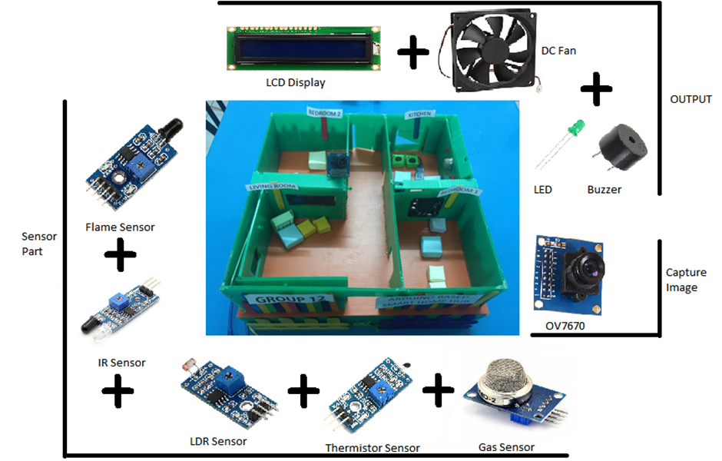

fan

Figure 2.0: Overall System Overview of Smart Home

This project is shown in Figure 2.0 which is using 5 different types of sensors to design this smart home system. The control part which is involve with fan and LED that are connected to LDR sensor. For other sensors, the results will be displayed using LED and buzzer to represent whether it is on or off. From the design, we use LCD to display the temperature value which is collated by the thermistor sensor and control the fan by the rise or fall of temperature value.

**2.2 Design Flow and Process**

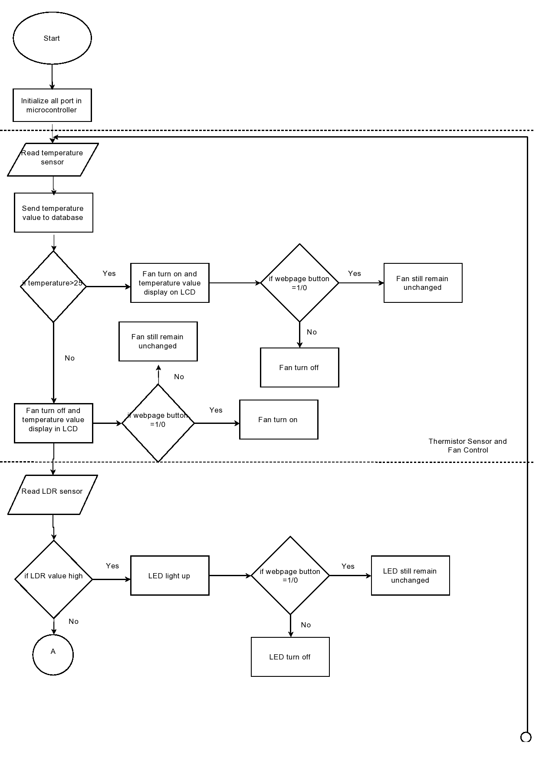

Figure 2.1: Flowchart of thermistor sensor and LDR sensor part

From the figure above, fan controlled by either temperature value or owner decision, and the temperature value is collated by thermistor sensor. The rise or fall of temperature will affect the fan whether turn on or off. For LDR part, it is also the same as fan, LED which is connected to LDR sensor either control by LDR value or owner decision.

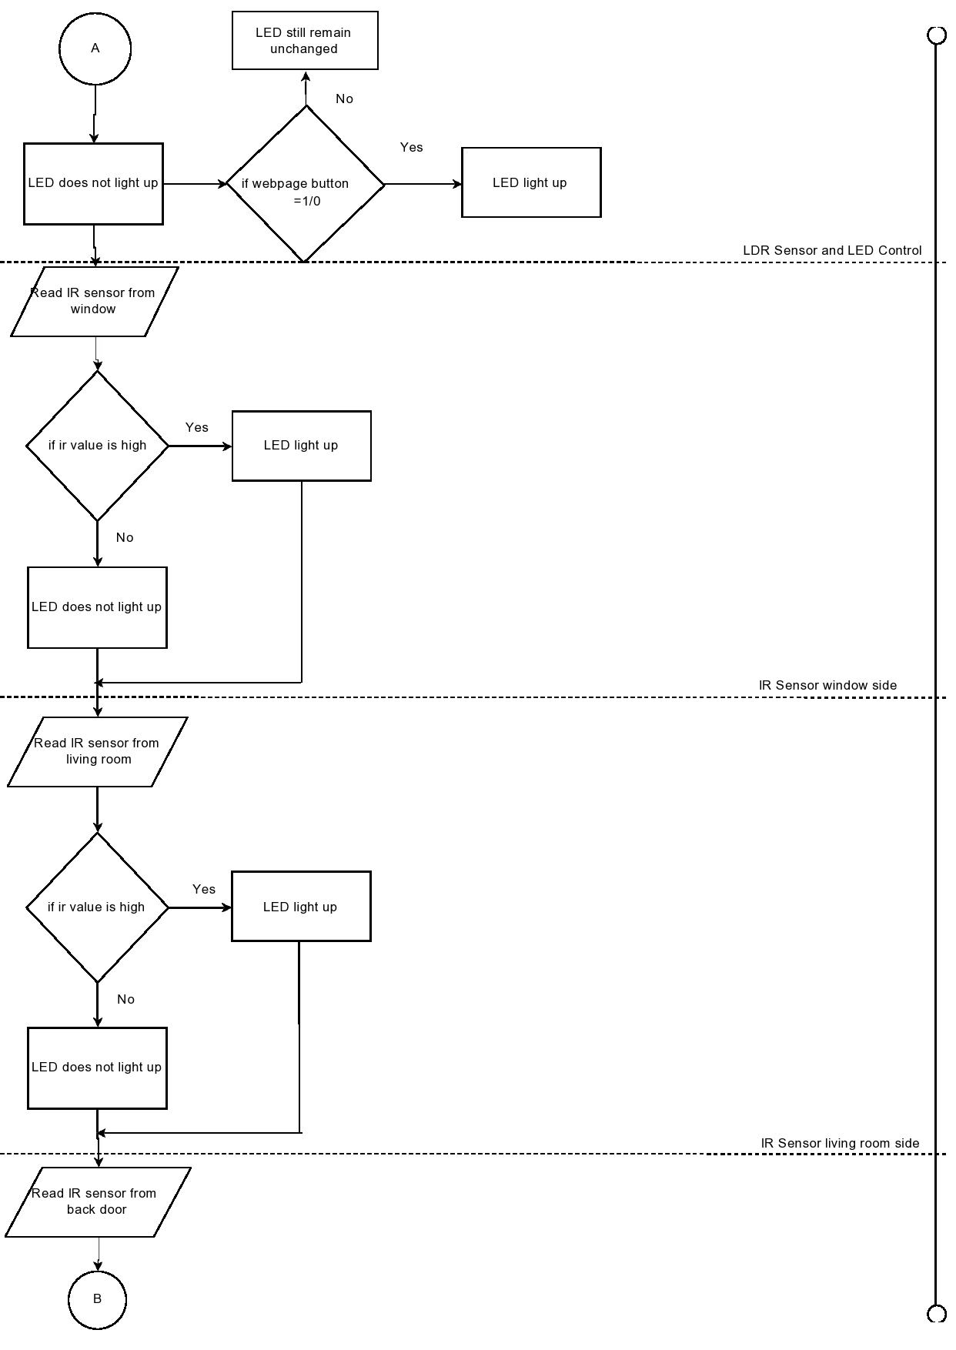

Figure 2.2: Flowchart of IR sensor (window and living room) part

For IR sensor, when the IR value is high, LED which is connected to each IR sensor respectively will light up. However, it will turn off when IR value is low. The data will be sent to the server for monitoring.

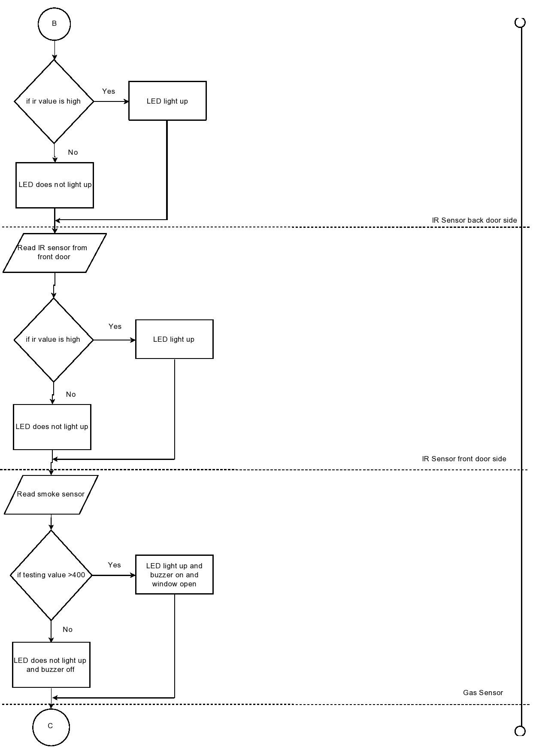

Figure 2.3: Flowchart of IR sensor (back door and front door) and gas sensor part

For IR sensor, both functions are same as above. When the testing value is higher than 400, LED will light up and buzzer will on. However, both will turn off when it is below testing value. The data will then send to the server for monitoring.

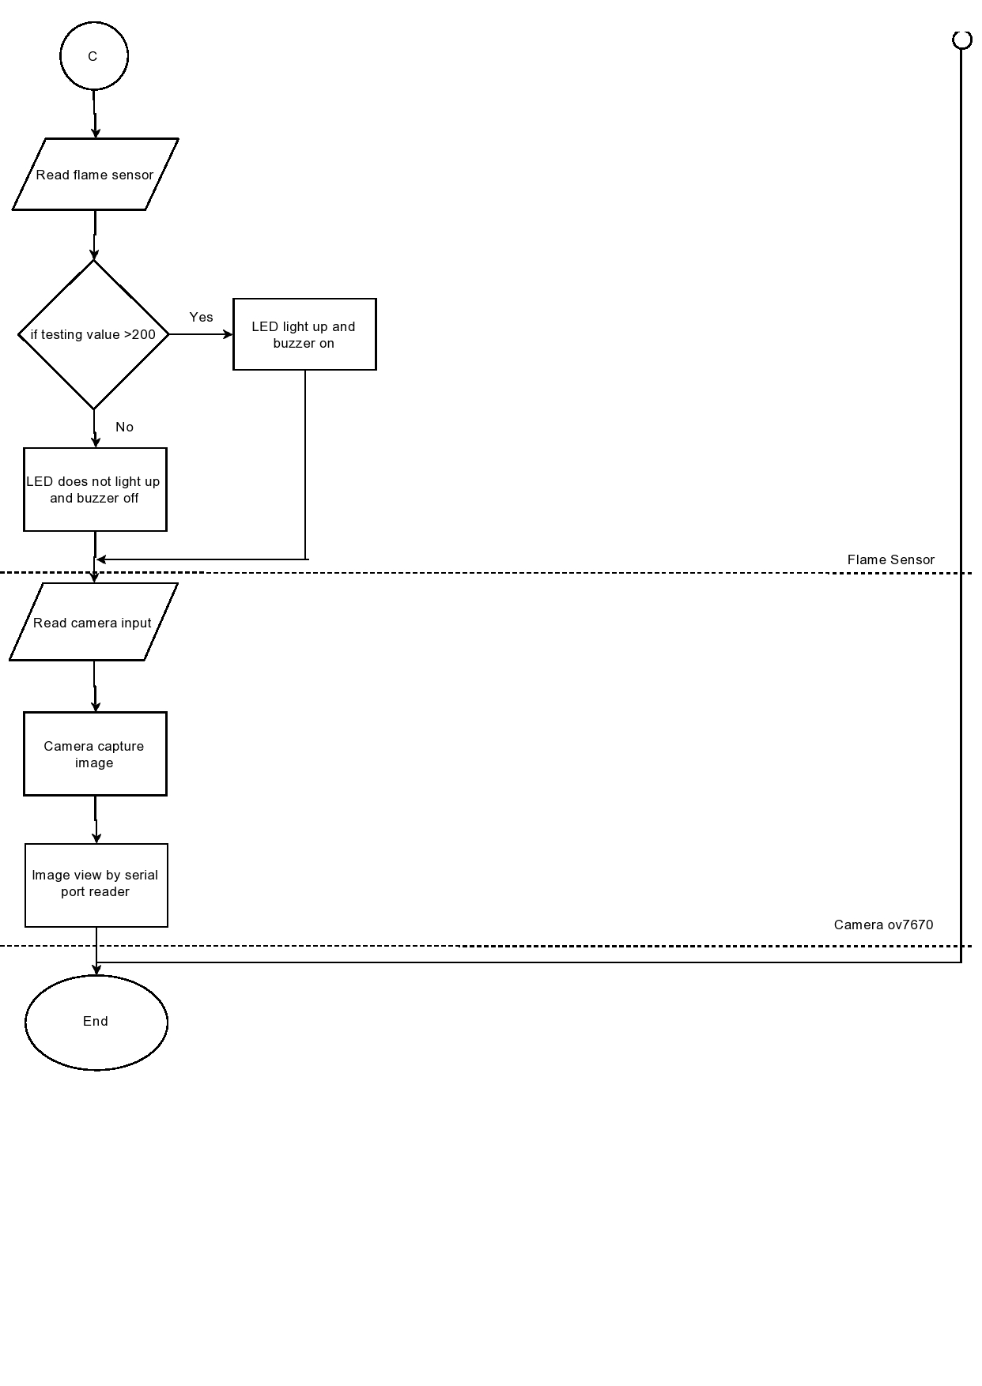Figure 2.4: Flowchart of flame sensor and camera ov7670

When testing value of flame sensor is above 200, the LED and buzzer will turn on whereas both will turn off when the testing value is below 200. The data will send to the server for owner monitoring. For camera, it will keep snapping as long as it still working.

**2.3 Design Complexity**

2.3.1 Block Diagram

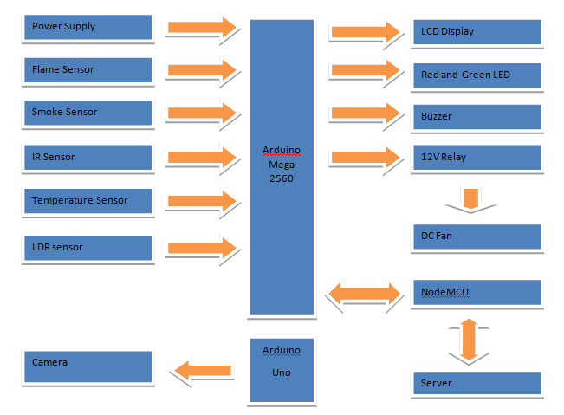

Figure 2.5: Block Diagram of the Project

Figure 2.5 shows the overall block diagram of this project. In the block diagram, there are few parts that act as main function in the project. This system provides a safety and secured home system when there is nobody in the house. There are five sensors that are connected to Arduino Mega 2560 as inputs which include flame sensor, smoke sensor, temperature sensor, InfraRed (IR) sensor and LDR sensor. The LCD display is used to display the value of temperature and the DC fan is controlled by the value of temperature. When the threshold values are above the set values for each sensor, the LED and buzzer will be triggered as an alarm to the house owner. Therefore, this will alert the owner if there is something unusual happens in house.

2.3.2 Schematic Diagram

Circuit connection for smart house based on Arduino is shown in Figure 2.6.

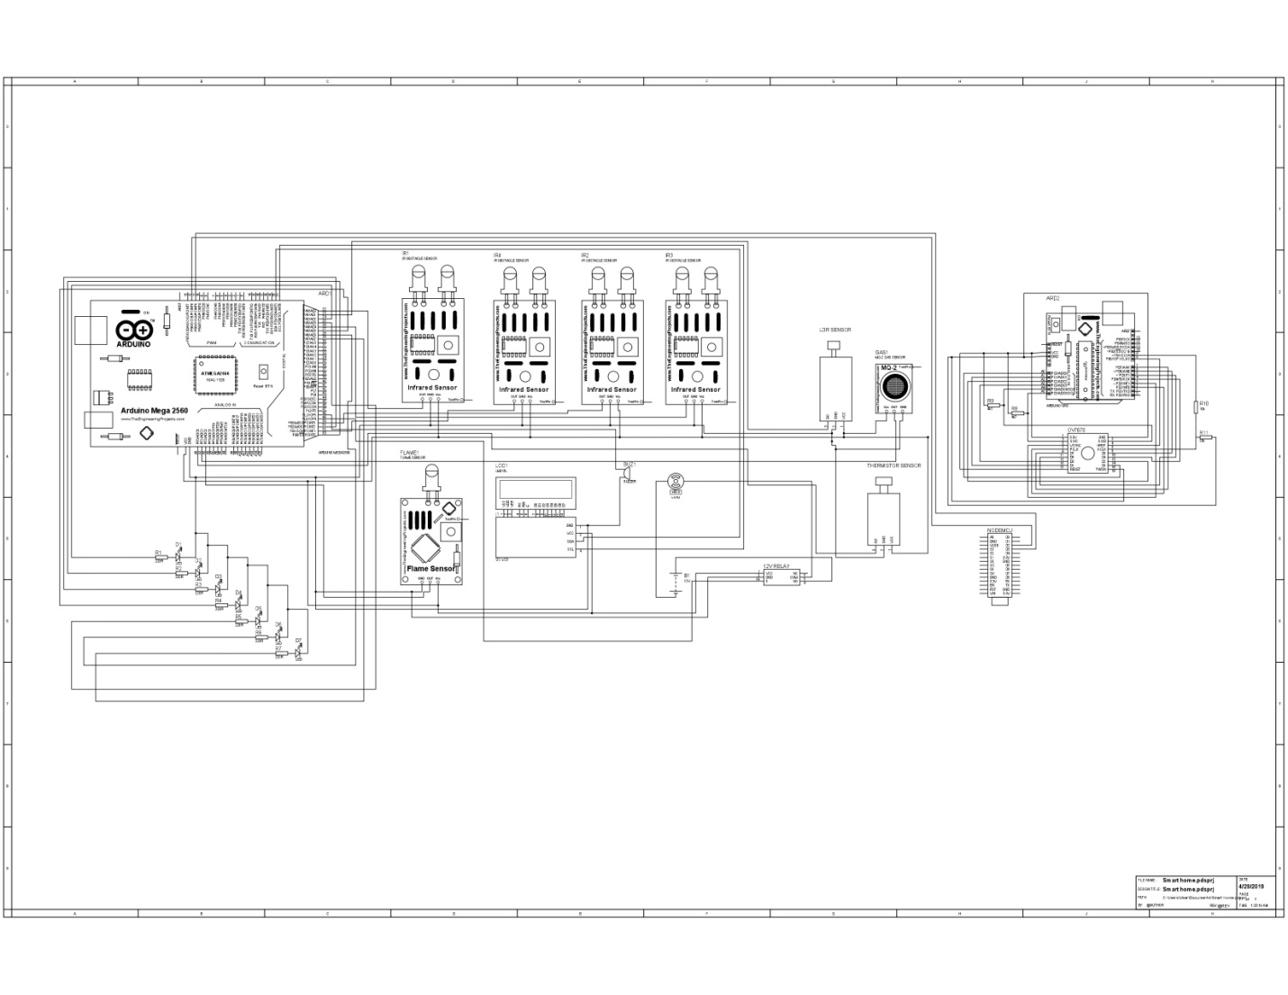

Figure 2.6: Schematic Diagram of the Project

To display all data through LCD, we use I2C module to simplify the connection between the LCD and Arduino with just only involving 4 pins. This I2C module is powered by 5V power supply. Its SDA and SCL pins are directly connected to SDA and SCL of Arduino Mega respectively. For each sensor, it is also powered by 5V from Arduino and each pin is connected to each sensor that we set.

For camera, each pin is connected to Arduino Uno as shown in schematic diagram. It is powered by 3.3V from Arduino and almost all the pins from Arduino Uno is used up for camera.

For the data uploaded to the server and control through server, nodeMCU pin D2 and D3 is connected to the pin 11 and 12 in Arduino Mega. Fan is connected to a 12V relay and it is connected to the pin 48 in Arduino Mega. Buzzer and LED is also set up with the pin we set respectively that shown in schematic diagram.

2.3.3 Technical Concept

2.3.3.1 LDR Sensor and LED Control

LDR sensor is used to detecting light intensity from surrounding. Data from LDR sensor are sent to the server through NodeMCU and it is also can be controlled through website by selecting the LED OFF or LED ON button to give command to LED either to turn off or on based on the condition detect by the LDR sensor. Figure 2.7 shows the coding part of LDR sensor.

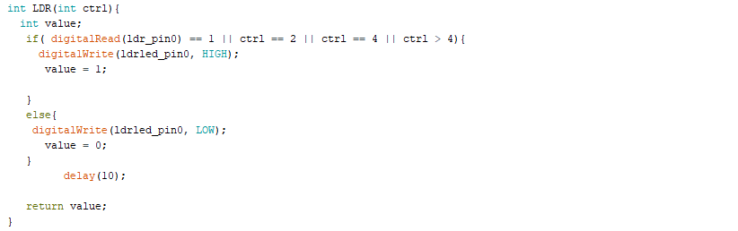

Figure 2.7: Coding part of LDR sensor

2.3.3.2 Flame Sensor

Flame sensor is used to detect fire. When the value collated by flame sensor is higher than the threshold value we set, LED and buzzer will be triggered. We install it in the kitchen for giving alert to owner when any fire is detected. Data from flame sensor will be sent to the server and it also can be monitored through website. Figure 2.8 shows the coding part of flame sensor.

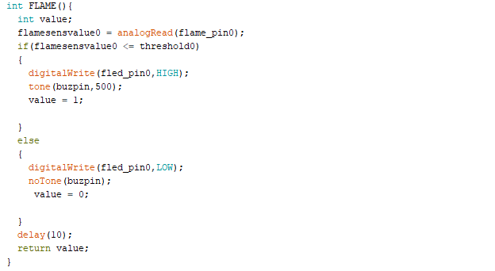

Figure 2.8: Coding part of flame sensor

2.3.3.3 InfraRed (IR) Sensor

This IR sensor module has a built-in IR transmitter and IR receiver that send out IR energy and looks for reflected IR energy to detect presence of any obstacle in front of the sensor module. We install it in window, front door, back door and living room. When detect presence of any obstacle, LED will light up. Data from IR sensor are sent to the server and it also can be monitored through the server. Figure 2.9 shows the coding part of IR sensor.

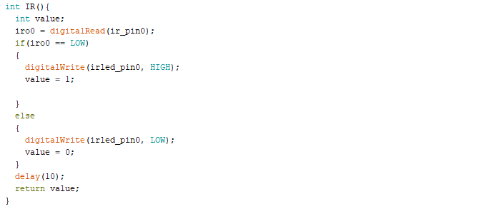

Figure 2.9: Coding part of IR sensor

2.3.3.4 Smoke Sensor

Smoke sensor is used to detect a variety of flammable gas. We install it to detect whether there are any gas leaking in the kitchen. It requires preheat up to 20 seconds for a stable detection. LED and buzzer will turn on when the testing value is above the value we set. Value from smoke sensor sent to the server and owner can be monitored through website. Figure 2.10 shows the coding part of Smoke sensor.

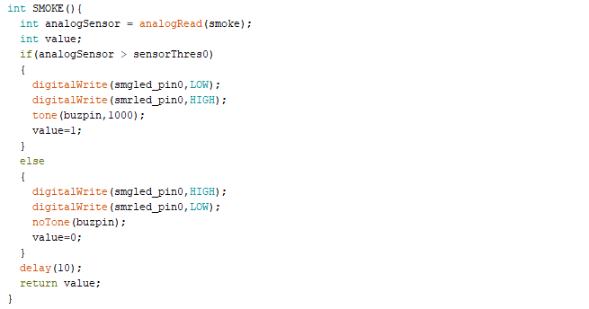

Figure 2.10: Coding part of Smoke sensor

2.3.3.5 Thermistor Sensor and Fan Control

Thermistor sensor is used to detect changing of surrounding temperature. We install it in the living room to detect temperature of the living room and the rise or fall of temperature value control the DC fan. Temperature value sent to the server through NodeMCU. Owner also can access to the website and selecting the ON or OFF button to control the fan. Figure 2.11 shows the coding part of thermistor sensor and fan control.

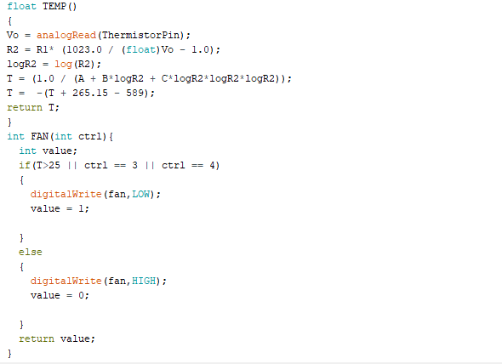

Figure 2.11: Coding part of Thermistor sensor and fan control

2.3.3.6 Arduino Camera OV7670

In order to ensure the security of the household from any attempt of house break-in and intruder, a video surveillance system has been deployed in this project. The camera will be turned on to capture the image of the unauthorized visitor as long as it still working. For this part, the camera *ov7670* will keep on snapping and the result will be shown in the serial port reader for *ov7670* to view the captured image. Figure 2.12 shows the coding part of camera ov7670.

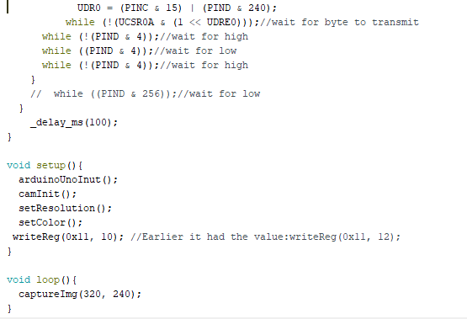

Figure 2.12: Coding part of camera

**2.4 Hardware Architecture**

2.4.1 Arduino Mega

The Arduino Mega shown in Figure 2.13 is a microcontroller board based on the ATmega2560.

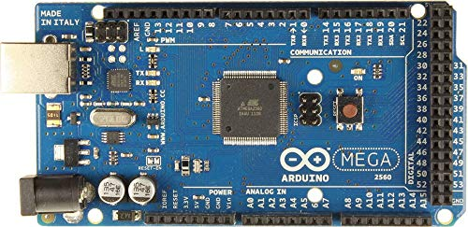

Figure 2.13: Arduino Mega Board

It has 54 digital input/output pins (of which 14 can be used as pulse width modulation(PWM) outputs), 16 analog inputs, 4 universal asynchronous receiver transmitter (UARTs)(hardware serial ports), a 16MHz crystal oscillator, a universal serial bus (USB) connection, a power jack, an in programming (ICSP) header, and a reset button. It contains everything needed to support microcontroller, simply connect it to a computer with a USB cable or power it with alternating current (AC) to direct current (DC) adapter or battery to get started. Arduino Mega is used to connect all sensors, fan, LCD, LED which is represent output of each sensor, buzzer and NodeMCU. Each IR sensor is connected to port 22, 52, 50 and 26 of Arduino Mega and LED to port 24, 53, 51 and 27 respectively. For flame, smoke and LDR sensor is connected to anolog port 1 and 2 whereas LDR is to the port 23. Each LED to represent the output for each sensor is connected to 28, 29 and 25. Thermistor sensor is connected to anolog port 0 and the temperature value will be sent to LCD for displaying which implant with a I2C that minimize the usage of wire is connected to SDA and SCL. Moreover, fan is connected to the port 49 which controlled by the rising and falling of the temperature value. Buzzer is connected to port 48 and it is used for flame sensor and smoke sensor to trigger it. Figure 2.13 and Table 2.1 show the Arduino Mega Board and its specifications respectively.

Table 2.1: The Technical Specification of Arduino Mega

|  |  |
| --- | --- |
| Microcontroller | ATmega2560 |
| Operating Voltage | 5V |
| Input Voltage(recommendation) | 7-12V |
| Input Voltage(limits) | 6-20V |
| Digital I/O Pins | 54 of which 14 provide PWM output |
| Analog Input Pins | 16 |
| DC Current per I/O Pin | 40mA |
| DC Current per 3.3V Pin | 50mA |
| Flash Memory | 256KB of which 8KB used by bootloader |
| SRAM | 8KB |
| EEPROM | 4KB |
| Clock Speed | 16MHz |

2.4.2 Arduino Uno R3

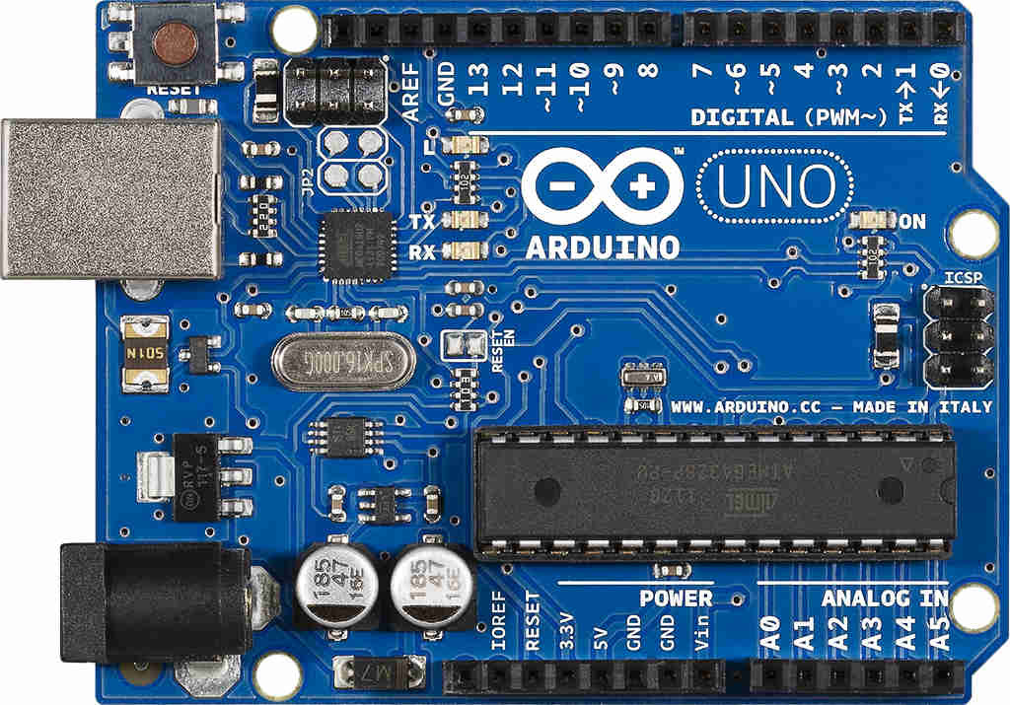

Figure 2.14: Arduino Uno Rev3

**Arduino Uno** is a microcontroller board based on 8-bit ATmega328P microcontroller. Along with ATmega328P, it consists other components such as crystal oscillator, serial communication, voltage regulator, etc. to support the microcontroller. Arduino Uno has 14 digital input/output pins (out of which 6 can be used as PWM outputs), 6 analog input pins, a USB connection, A Power barrel jack, an ICSP header and a reset button. For the purpose we used this Arduino Uno is due to the delay time for camera to capture an image is too long so it may affect the data collated in Arduino Mega, therefore, we suggest to separate and used it for installation of camera. The image is shown in the serial port reader for viewing and it also can save the image to the local disc in computer. Figure 2.14 and Table 2.2 show the Arduino Uno Board and its specifications respectively.

Table 2.2: The Technical Specification of Arduino Uno

|  |  |
| --- | --- |
| Microcontroller | ATmega328P |
| Operating Voltage | 5V |
| Input Voltage(recommendation) | 7-12V |
| Input Voltage(limits) | 6-20V |
| Digital I/O Pins | 14 of which 6 provide PWM output |
| Analog Input Pins | 6 |
| DC Current per I/O Pin | 40mA |
| DC Current per 3.3V Pin | 50mA |
| Flash Memory | 32KB of which 0.5KB used by bootloader |
| SRAM | 2KB |
| EEPROM | 1KB |
| Clock Speed | 16MHz |

2.4.3 Liquid Crystal Display (LCD)

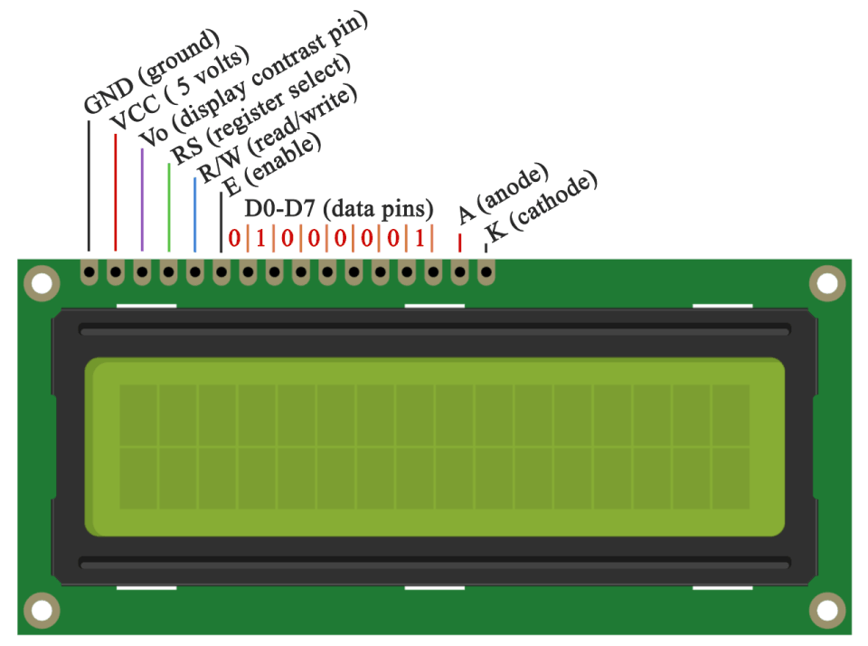

Figure 2.15: LCD Display

Liquid Crystal Display (LCD) is been made use as a part of all electronics works to show the value of temperature. Figure 2.15 shows a 16x2 alphanumeric LCD is most generally utilized module of LCD these days. There are a few other kind of LCD obtainable too. The intention for selecting LCD above other display components is because it is:

* Low cost
* Easily programmable
* Large number of display character etc.

The 16x2 LCD owns 2 horizontal lines, embracing a room of 16 displaying characters. It has types of registers in-built:

* Command register
* Data register

Command register is made use to supplement special commands into the LCD. A command is a special form of data which makes use of giving internal commands to LCD. Whereas data register is made use to supply a data character into the LCD display. Changing of surrounding temperature is detecting by the thermistor sensor and value of temperature will be displayed into the LCD for owner monitoring.

2.4.4 NodeMCU

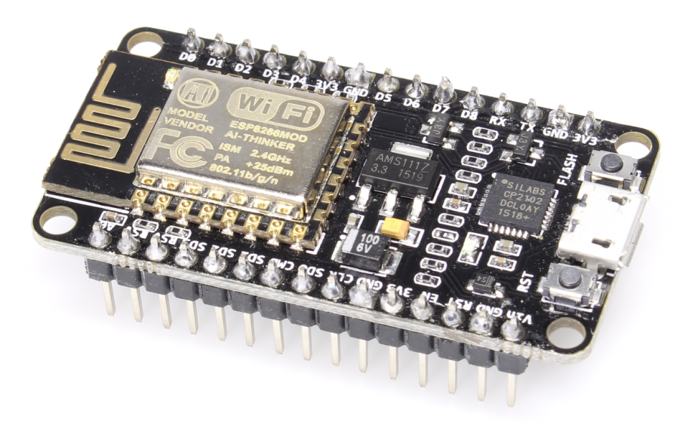

Figure 2.16: NodeMCU

General-purpose input/output (GPIO) is a pin on an IC (Integrated Circuit). It can be either input pin or output pin, whose behavior can be controlled at the run time. NodeMCU Development kit provides access to these GPIOs of ESP8266. The only thing to take care is that NodeMCU Dev kit pins are numbered differently than internal GPIO notations of ESP8266 as shown in below figure and table. For example, the D0 pin on the NodeMCU Dev kit is mapped to the internal GPIO pin 16 of ESP8266. We used it as an internet connection and send data to our server. It is low-cost and low energy consumption. Figure 2.16 and Table 2.3 show the NodeMCU and its specifications respectively.

Table 2.3: The Technical Specification of NodeMCU

|  |  |
| --- | --- |
| Operating Voltage | 3V ,5V (used with 3.3v Regulator which inbuilt on Board using Pin VIN) |
| Type of Network | * WEP * WPA/WPA2 authentication * Open network |
| CPU | ESP8266 |
| Memory | 128K Bytes |
| Storage | 4M Bytes |
| Power By | USB |
| Operating System | XTOS |

2.4.5 Infrared Sensor Module

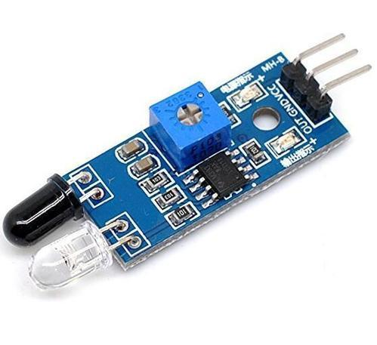

Figure 2.17: Infrared Sensor Module

This infrared sensor module has a built-in IR transmitter and IR receiver that sends out IR energy and looks for reflected IR energy to detect presence of any obstacle in front of the sensor module. The module has an on-board potentiometer that allows you to adjust detection range. It has 3.0mm mounting holes for easy mounting plus a male header for ease of connection. Figure 2.17 and Table 2.4 show the Infrared Sensor Module and its specifications respectively.

Table 2.4: The Technical Specification of Infrared Sensor Module

|  |  |
| --- | --- |
| Operating Voltage | 3V-6V |
| Detection Angle | 35° |
| Detection Range | 2cm-30cm(adjustable) |
| Current Consumption | 3.3V-23mA at 5.0V-43mA |
| Pin available | * VCC- 3.3V-5V * GND-0V * OUT-Digital Output Pin |

2.4.6 Flame Sensor Module

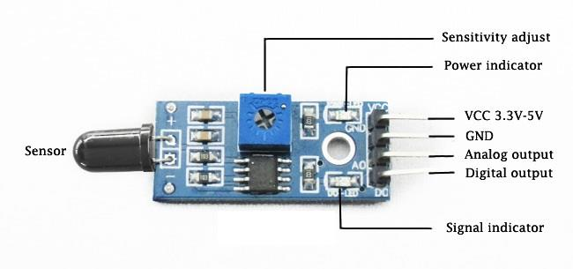

Figure 2.18: Flame Sensor Module

The flame sensor can detect flame and infrared light sources with wavelengths ranging from 760 nm to 1100 nm. It uses the LM393 comparator chip, which gives a clean, stable digital output signal and driving ability of 15mA. This flame detector can be used in fire alarms and other fire detecting devices. It is easily to obtain and programmable as well as low cost. Figure 2.18 and Table 2.5 show the Flame Sensor Module and its specifications respectively.

Table 2.5: The Technical Specification of Flame Sensor Module

|  |  |
| --- | --- |
| Operating Voltage | 3.3V-5V |
| Operating Current | 15mA |
| Detection Range | 760nm-1100nm(adjustable) |
| Detection Angle | Around 60° |
| Pins available | * VCC-3.3V-5V * GND-0V * Do-Digital Output * Ao-Analog Output(not available in 3-pin flame sensor) |
| Chip available | LM393 comparator |

2.4.7 Light Dependent Resistor Sensor Module (LDR)

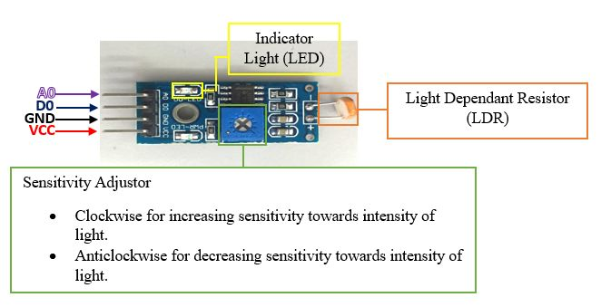

Figure 2.19: LDR Sensor Module

LDR sensor module is used to detect the intensity of light. It is associated with both analog and digital output pin labelled as AO and DO respectively on the board. When there is light, the resistance of LDR will become low according to the intensity of light. The greater the intensity of light, the lower the resistance of LDR. The sensor has a potentiometer knob that can be adjusted to change the sensitivity of LDR towards light. Figure 2.19 and Table 2.6 show the LDR Sensor Module and its specifications respectively.

Table 2.6: The Technical Specification of LDR Sensor Module

|  |  |
| --- | --- |
| Operating Voltage | 3.3V-5V |
| Operating Current | 15mA |
| Pins Available | * VCC-3.3V-5V * GND-0V * Do-Digital Output * Ao-Analog Output(not available in 3-pin ldr sensor module) |
| Sensitivity | Adjustable using on board potentiometer |

2.4.8 Thermistor Sensor Module

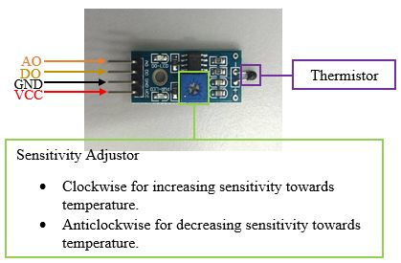

Figure 2.20: Thermistor Sensor Module

Thermistor Sensor Module is used to sense temperature and convert it into output signals. It is associated with both analogue and digital output pin labelled as AO and DO respectively on the board. Thermistor Sensor Module is made of semiconductor materials. Basically, thermistor sensors are mostly Negative Temperature Coefficient (NTC), which means NTC thermistors will have their electrical resistance decreased when subjected to an increase in body temperature. This module has a potentiometer knob that can be adjusted to change the sensitivity of thermistor towards temperature. We used it to sense the temperature inside the room and display it through LCD display. Figure 2.20 and Table 2.7 show the Thermistor Sensor Module and its specifications respectively.

Table 2.7: The Technical Specification of Thermistor Sensor Module

|  |  |
| --- | --- |
| Operating Voltage | 3.3V-5V |
| Pins Available | * VCC-3.3V-5V * GND-0V * Do-Digital Output * Ao-Analog Output (not available in new version of thermistor sensor module) |
| Sensitivity | * Adjustable using on board potentiometer * Sensitive to environment temperature |
| Temperature Range | Ao is around 1.45V at 27 degree Celsius. Higher temperature reduces the voltage at Ao |
| Chip available | On board comparator for digital output threshold setting |

2.4.9 MQ-2 Gas Sensor Module

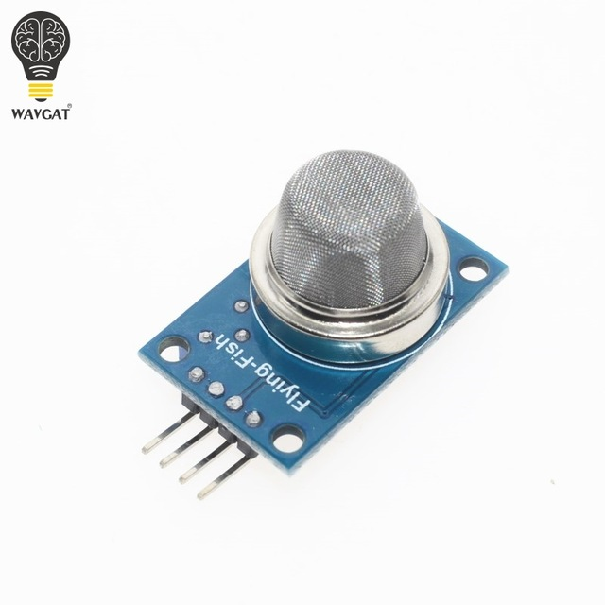 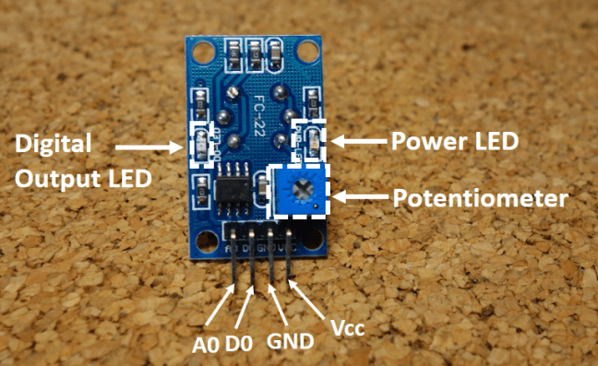

Figure 2.21: MQ-2 Gas Sensor Module

MQ-2 gas sensor sensitive material used in the clean air low conductivity tin oxide (SnO2). When there is the environment in which the combustible gas sensor, conductivity sensor with increasing concentration of combustible gases in air increases. Using a simple circuit to convert the change in conductivity of the gas concentration corresponding to the output signal. This sensor can detect a variety of flammable gas, is a low-cost sensor for a variety of applications. In this project, the MQ-2 gas sensor is used to detect whether there is any gas leaking in the kitchen. It requires preheat up to 20 seconds for a stable detection. Figure 2.21 and Table 2.8 show the MQ-2 Gas Sensor Module and its specifications respectively.

Table 2.8: The Technical Specification of MQ-2 Gas Sensor Module

|  |  |
| --- | --- |
| Operating Voltage | 5V |
| Operating Current | 150mA |
| Pins Available | * VCC-3.3V-5V * GND-0V * Do-Digital Output * Ao-Analog Output (not available in 3-pins of MQ-2 gas sensor module) |
| Sensitivity | Adjustable using on board potentiometer |
| Gas Type (MQ-2) | Methane, Butane, LPG, Smoke |

2.4.10 Arduino Camera OV7670

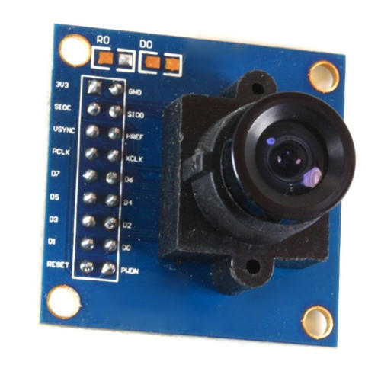

Figure 2.22: Arduino Camera OV7670

The OV7670 Camera Module is a small image sensor, low operating voltage, providing all functions of a single chip of VGA camera and image processor. Through SCCB bus control, the sensor can output the whole frame, sampling, and various resolution 8 bits of data.  The product VGA image can reach up to a maximum of 30 frames per second. Users can completely control the image quality, data format and transmission mode. All the process of image processing functions can through the SCCB programming interface, including gamma curve, white balance, saturation and chroma. We install it in the living room for capturing the break-in intruders. The camera will keep snapping and the image will be displayed on the serial port reader for viewing. Image also can be saved in the local disc of computer. Figure 2.22 and Table 2.9 show the Arduino Camera and its specifications respectively.

Table 2.9: The Technical Specification of Arduino Camera OV7670

|  |  |
| --- | --- |
| Power Source | 3.3V |
| Photosensitive array | 640x480 pixel |
| IO Voltage | 2.5V-3V |
| FOV | 25 ° |
| Maximum Zhen rate | 30fps VGA |
| SNR | 46dB |
| Dynamic Range | 52dB |
| Power Operation | 60mW/15fpsVGAYUV |

2.4.11 DC Fan

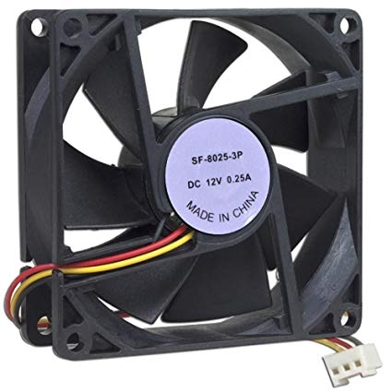

Figure 2.23: DC Fan

DC fan is been made used as part of components to represent as a fan in any of the prototype. Figure 2.23 and 2.10 show the DC fan and its specification. It is widely use in any prototype because it is low cost, easily programmable, easily get. It also has different type of size but all the function is still the same. Our main function of fan is controlled by the value of temperature and also the decision of owner either it will turn on or off automatically by changing of temperature value or by selecting the ON or OFF button on the website.

Table 2.10: The Technical Specification of DC Fan

|  |  |
| --- | --- |
| Operating Voltage | 12V |
| Power | 1.8W-5.76W |
| Current Type | DC |

2.4.12 Relay

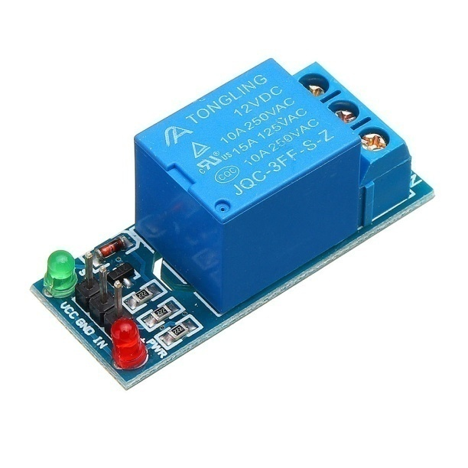

Figure 2.24: 12V Relay

This is 12V relay breakout board. Yet, to control it, 3.3V to 5.0V logic is sufficient. The relay terminals (COM, NO and NC) are brought out using screw terminal. On-board relay is rated at 10A. It can be used in many applications: controlling high voltage, high current load such as motor, solenoid valves, lamps and AC load. It also comes with 2 LEDs to indicate the status power (VCC) and status of relay. We used it connect to fan for controlling high voltage of the power supply. Figure 2.24 and table 2.11 show the 12V relay and its specification.

Table 2.11: The Technical Specification of 12V Relay

|  |  |
| --- | --- |
| Operating Voltage | 3.3V-5V |
| Max Switching Current | 10A |
| Max Switching Voltage | 250VAC/110VDC |
| Max Allowable Power Force | 800VAC/240W |

2.4.13 Light Emitting Diode (LED)

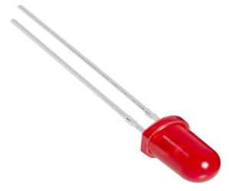

Figure 2.25: LED Light Bulb

The LED is a light source which uses semiconductors and electroluminescence to create light. The advantages are it is an energy sufficient source of light for short distances and small areas and it requires only 30 to 60mm to operate. Besides, it is durable and shockproof unlike glass bulb lamp types and directional nature is useful for some applications like reducing stray light pollution on streetlights. We used it as an output for each sensor when detected obstacle and above certain value, it will light up. Figure 2.25 shows the LED light bulb.

2.4.14 Alarm unit

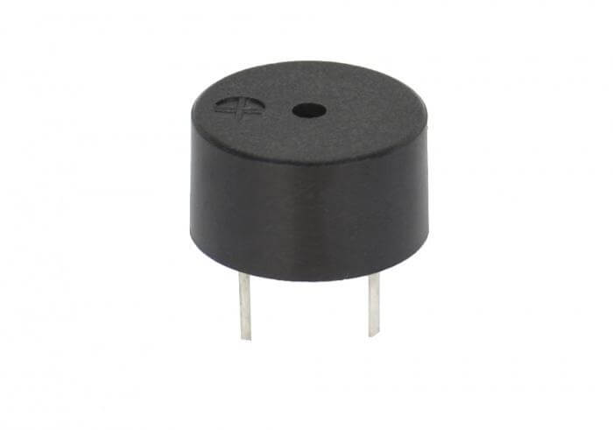

Figure 2.26: Buzzer

Buzzer is used for giving warning signal. It indicates that there are intruders inside house. Here we are using 5V DC, HXD piezo-buzzers. Piezo-buzzers are working under the principle of piezoelectric effect. When a mechanical pressure is applied to certain materials it produces electricity and vice-versa. When exposed to an alternating electric field they stretch or compress, in accordance with the frequency of the signal by this means producing sound. Figure 2.26 show the buzzer.

**2.5 Software Architecture**

2.5.1 Arduino IDE

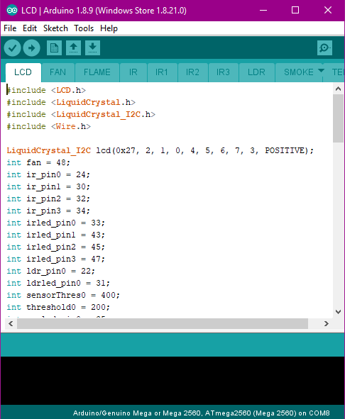

Figure 2.27: Program Coding in Arduino IDE

The purpose of using this software is to upload the coding to the compatible Arduino board that we used. It is easy compiling and different library needed to read the code respectively. The Arduino Integrated Development Environment or Arduino Software (IDE) contains a text editor for writing code, a message area, a text console, a toolbar with buttons for common functions and series of menus. It connects to the Arduino hardware to upload programs and communicate with them. Figure 2.27 shows some of the program coding in Arduino. The precautions such as measuring the obstacle pass by using IR sensor, detecting flame and smoke, turning on the LED and alarm unit are defined.

2.5.2 Serial Port Reader

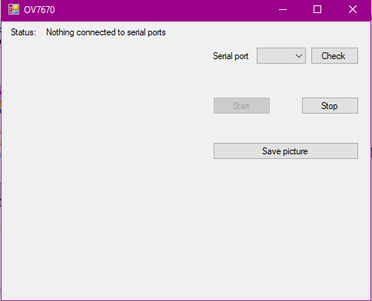

Figure 2.28: Serial Port Reader

Serial port reader is to show the captured image which capture by camera ov7670 for viewing. Image can be saved and review by the owner when it is necessary.

**Summary**

From this design, we used different types of sensor to improve the security of this smart home system in order to develop a safety and secured smart house that can be monitored and controlled when owner is away. Moreover, also to improve the security system, we used camera for capturing the status of the house. When unusual case happens, owner can review the image that captured through camera. We are using 4 IR sensor to detect obstacle in different area of the house widen the area of detection.

**CHAPTER 3**

**RESULT AND DISCUSSIONS**

**3.0 Results**

This section discusses the real result obtained from the developed Arduino Based Smart Home Hub. Figure 3.0 show the overall system project that has been integrated and assembled accordingly.

Room number 2 with green LED

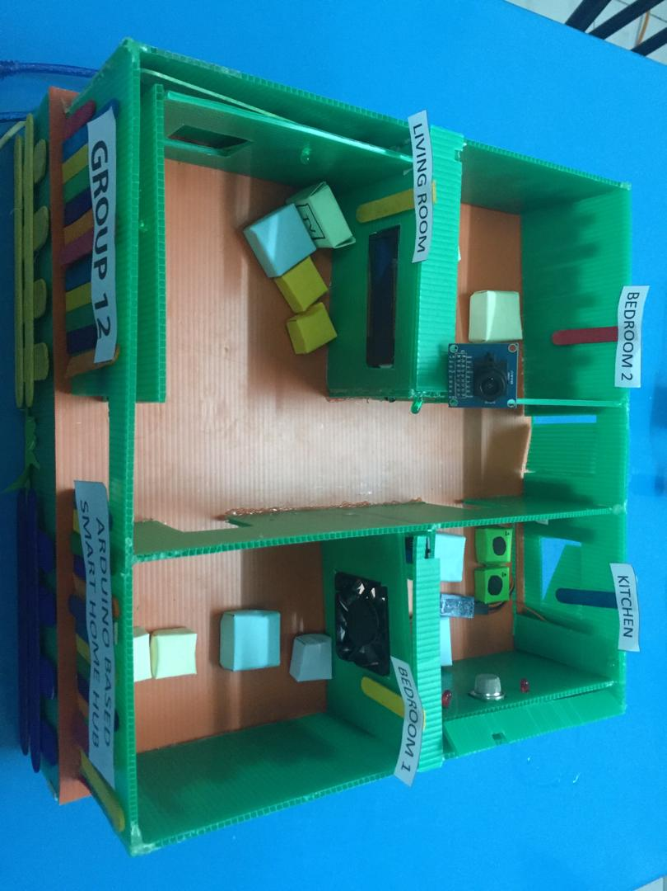

Living Room with IR sensor in the middle of the house, IR sensor near to window and front door, camera, LED, buzzer and Liquid Crystal Display (LCD)

Room number 1 with temperature sensor and fan

Kitchen with gas sensor, flame sensor, red LED, and buzzer for alarm

Figure 3.0: Overall System

This prototype consists of two number of rooms, one kitchen, and one living room. The first room consists of a temperature sensor and DC fan. The second bedroom, it consists of LDR sensor and LED. Inside the living room, it consists of two IR sensor near to the window and from the door. Inside living room also, it consists of LCD to display temperature. Last but not least, inside the kitchen, there are also consists of gas sensor to sense any leaking gas, the flame sensor to detect fire and IR sensor near to back door.

**3.1 Camera Surveillance System in Living Room**

This section shows the result of sensors in living room.

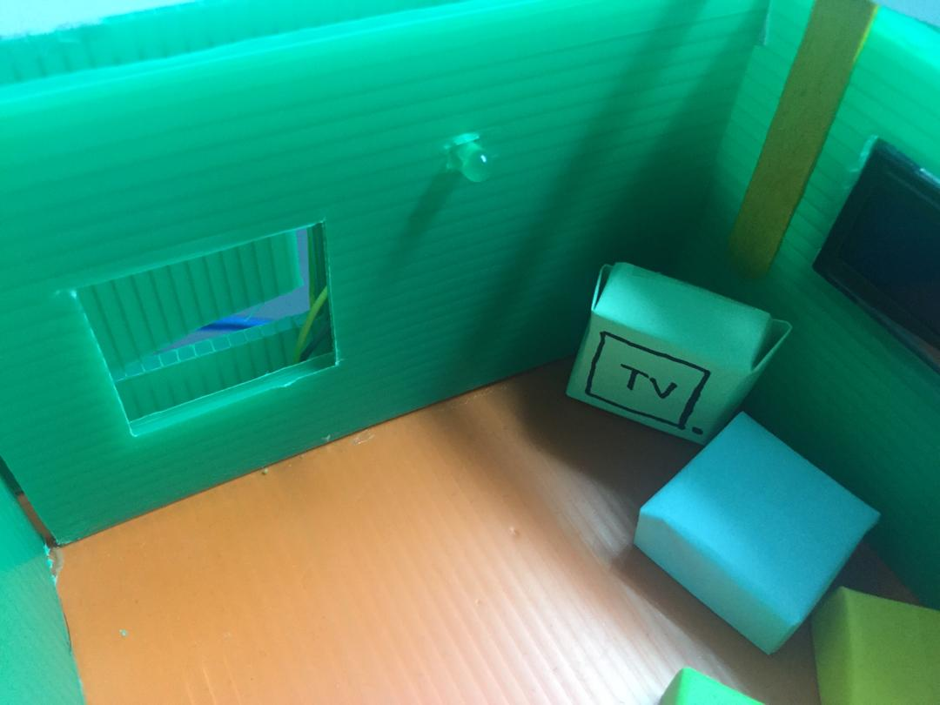  

a) b) c)

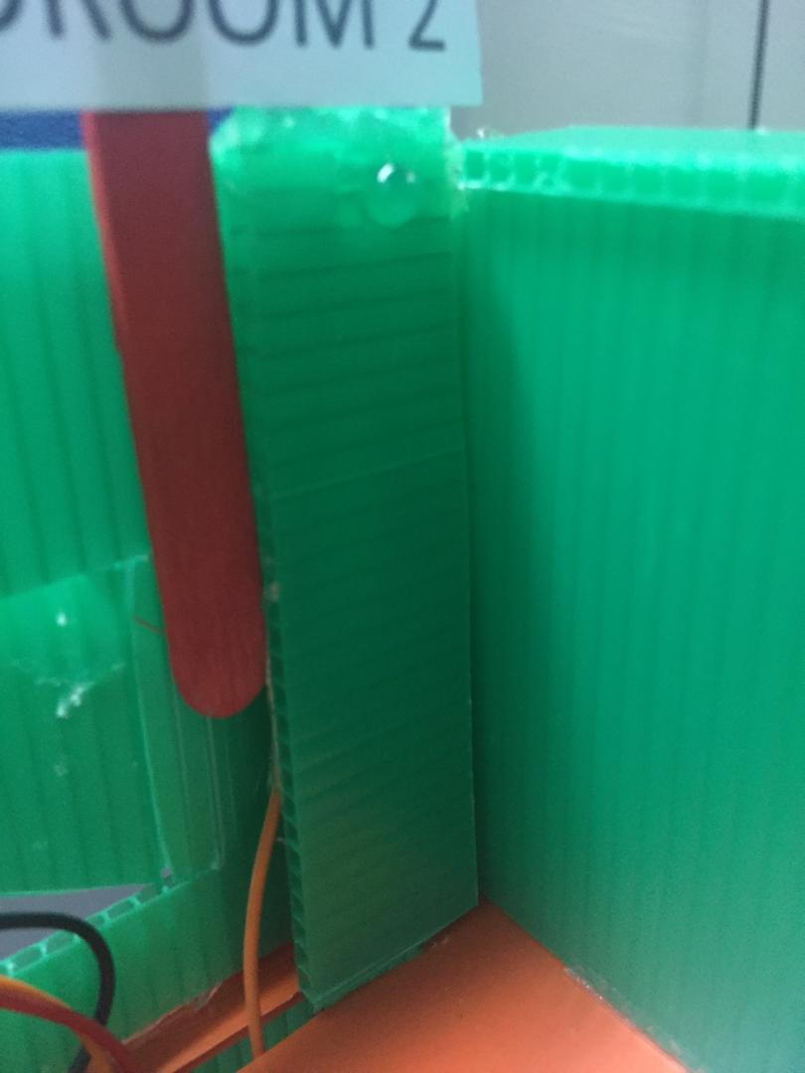

c)

Figure 3.1: No intruder (a) Window (b) Middle of living room (c) Front door (d) Back door

Figure 3.1 shows the condition where there is no intruder by detecting infrared light from the intruder. IR sensor was used to detect infrared light from intruder. LED and buzzer will not turn on when there is no intrusion.

 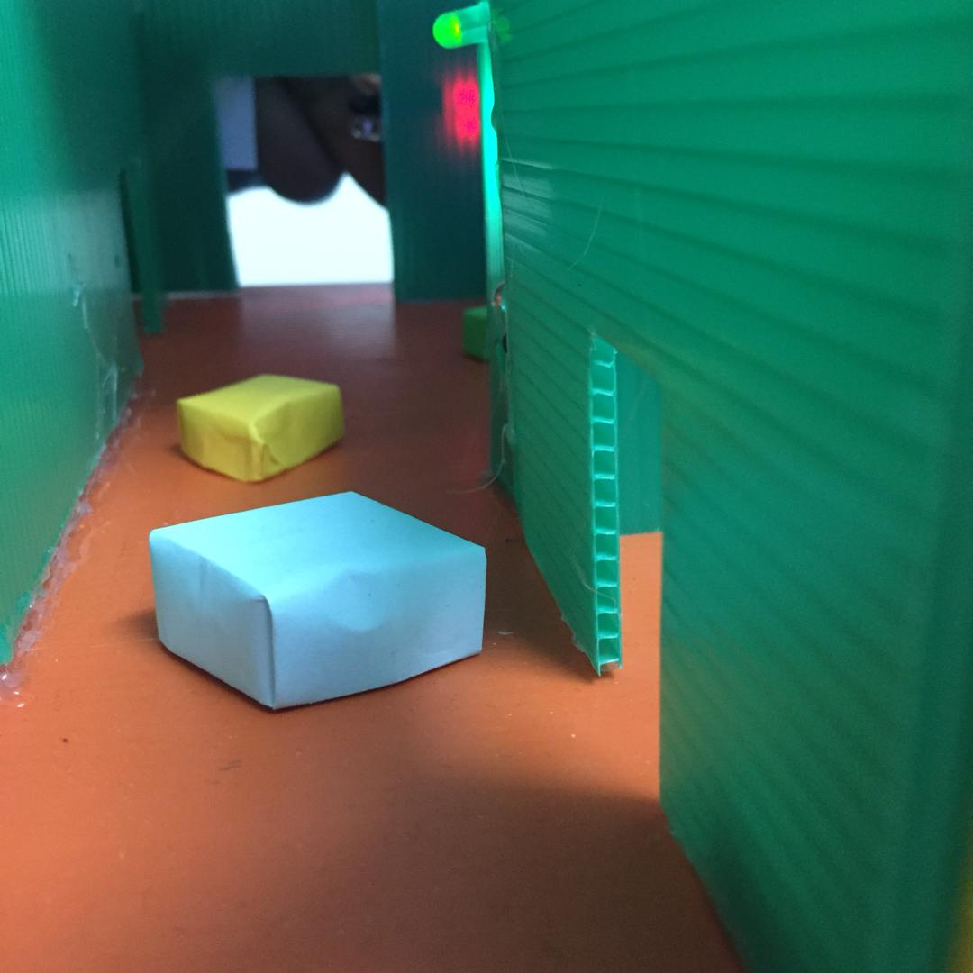 

(a) (b) (c)

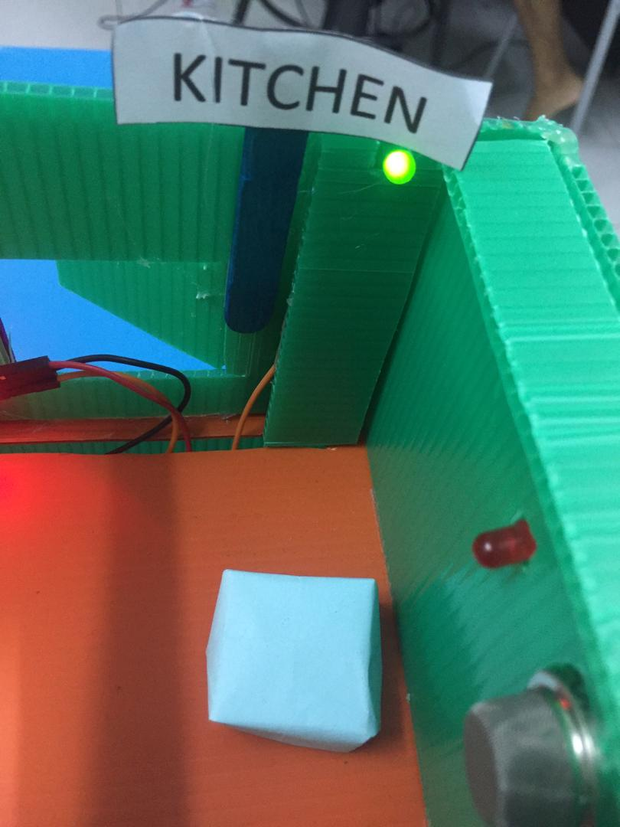

(d)

Figure 3.2: Intruder Detected (a) Window (b) Middle of living room

(c) Front Door (d) Back door

Figure 3.2 shows the condition where there is intruder by detecting infrared light from intruder using IR sensor. LED and buzzer will turn on to alert the owner that there is an intrusion in the house.

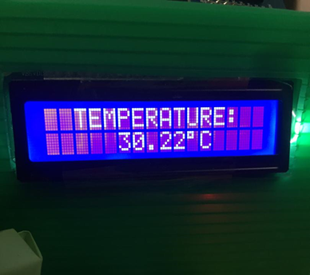

Figure 3.3: Value of temperature inside room number 1

Figure 3.3 shows the value of temperature inside the house. The temperature sensor is used to sense the real-time temperature inside the house. The value of temperature will be showed in the LCD.

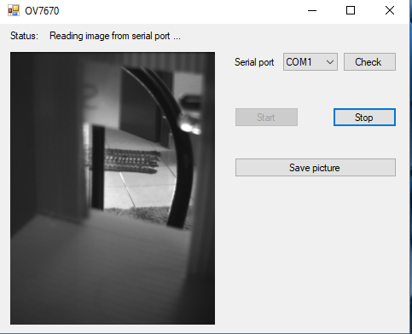

Figure 3.4: The image captured from the camera showing the front door

Figure 3.4 shows the image captured from the camera. The camera will always turn on to monitor the house. The picture of the camera will be saved into local storage. This functionality, can help user to monitor the house when they are away.

**3.2 Temperature control in Bedroom 1**

This section shows the result of sensors in bedroom 1.

 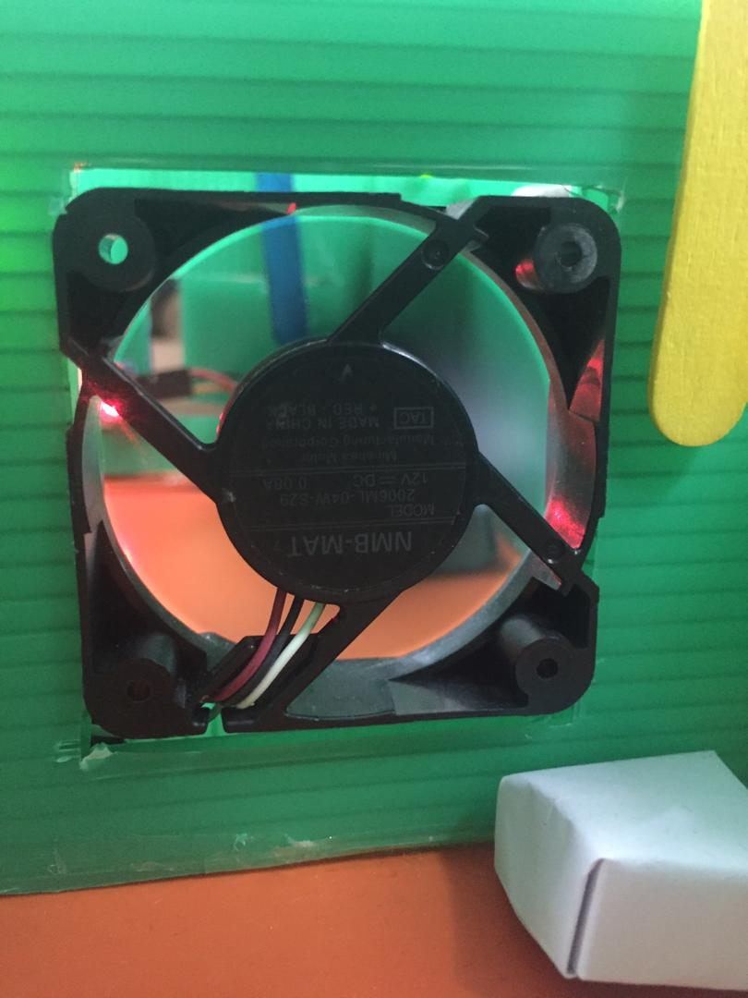

(a) (b)

Figure 3.5: Fan (a) OFF (b) ON

Figure 3.5 shows fan inside bedroom one. When the temperature value is above 25 ̊C, the fan will be turned on automatically in order to make the room comfortable to be lived. Temperature sensor was used to sense real-time temperature inside the room.

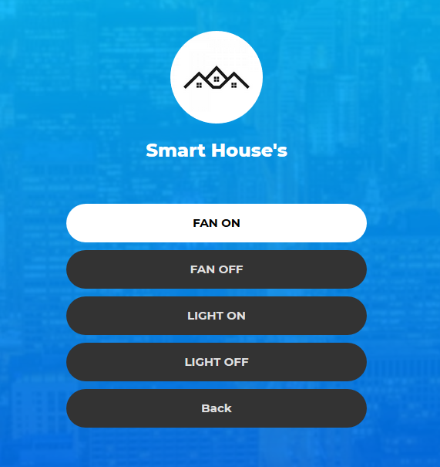 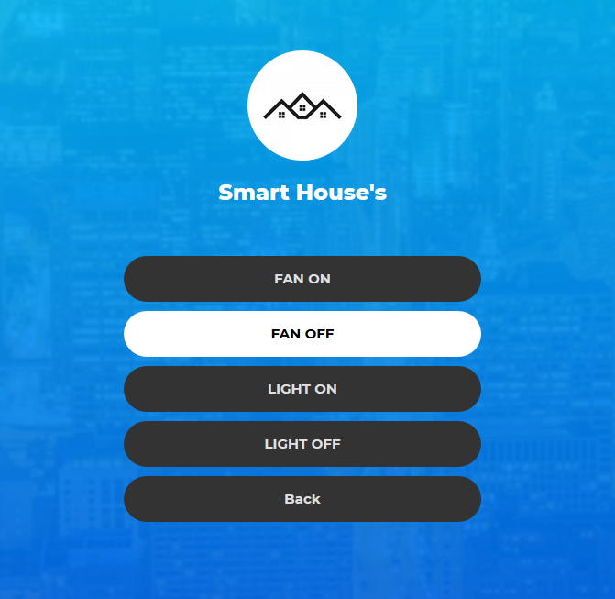

(a) (b)

Figure 3.6: Webpage control (a) Fan ON (b) Fan OFF

Figure 3.5 shows control section inside the webpage for fan. The fan can be controlled from the webpage to prevent the fan to turn on the whole time when temperature is above 25 ̊ C to prevent electrical waste. This remote control can also help the house owner to check if they forgot to switch off the fan when they are away. Such control not only can save energy, but also prevent any short circuit to when the fan is not turn off for a long time. The fan can be on and off freely from the webpage.

**3.3 Light Control in Bedroom 2**

This section shows the result of sensors in bedroom 1.

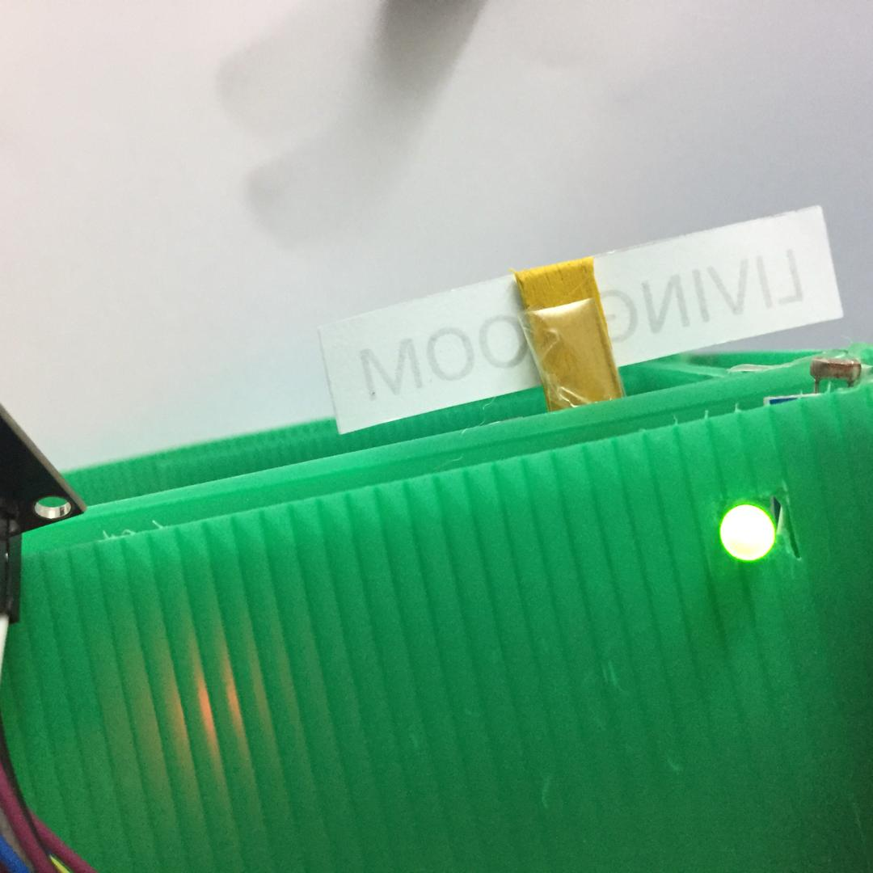 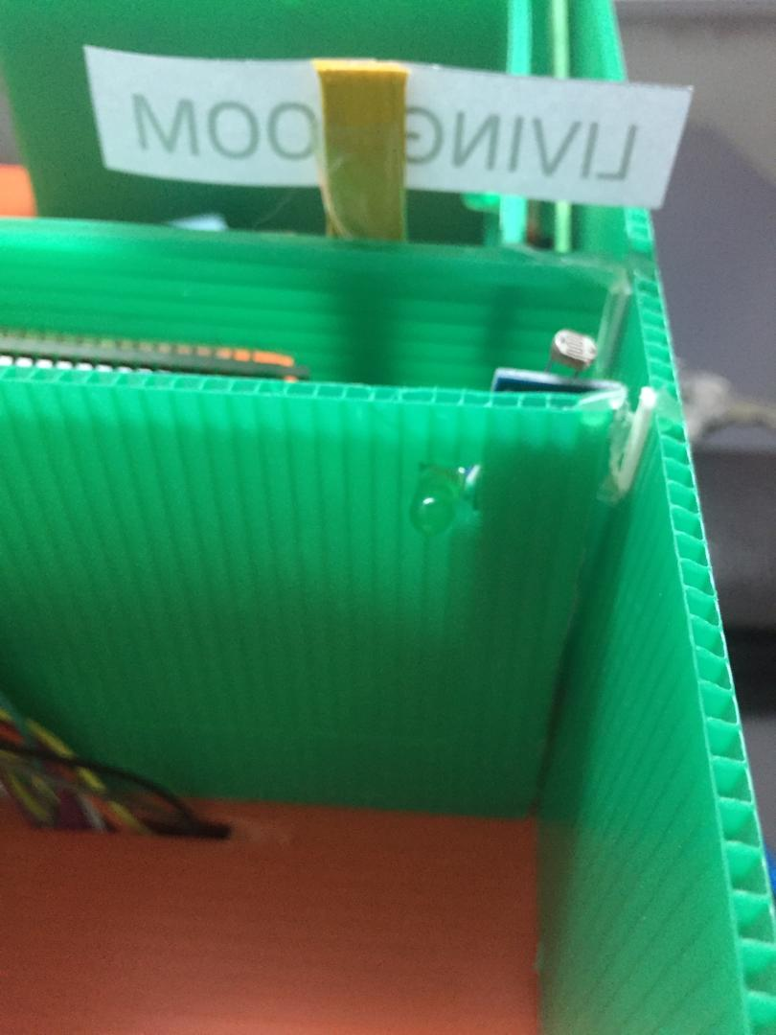

(a) (b)

Figure 3.7: Light (a) ON (b) OFF

Figure 3.7 shows the LED light indicating for lamp inside the room. The LED will automatically turn on when the LDR sensor detect no presence of light inside the room. This is for electricity saving. So, the light will not be turned on during the day time.

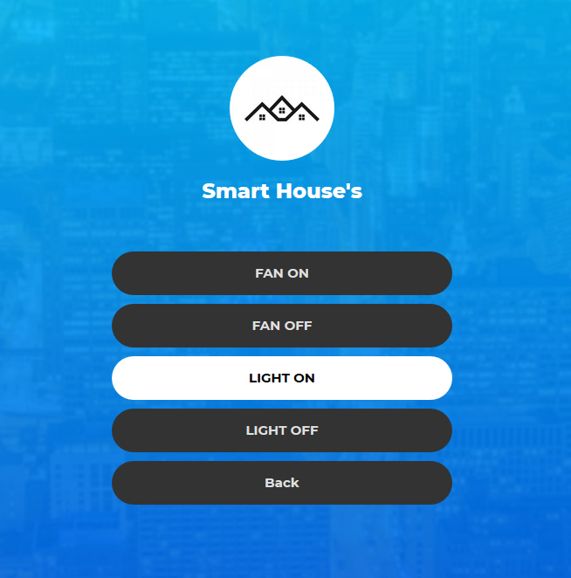 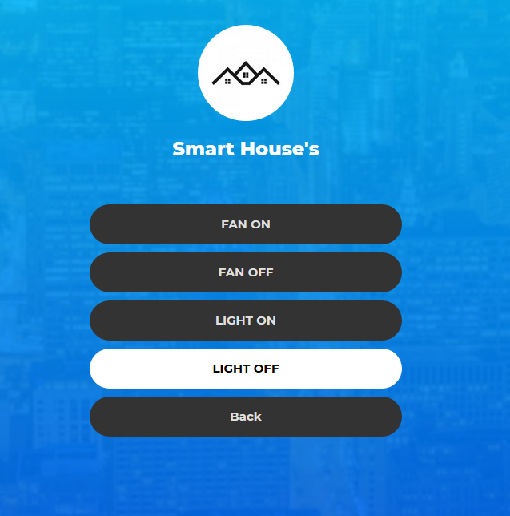 (a) (b)

Figure 3.8: Webpage control (a) Light ON (b) Light OFF

Figure 3.8: shows the controller for LED light. The LED also can be controlled from the webpage. When user want to sleep, the user can just close the LED from webpage even then LDR still detect darkness.

**3.4 Smoke and Flame Detection in Kitchen**

This section shows the result of the flame sensor and gas sensor deployed in the kitchen area. The flame used to detect fire and gas sensor to detect gas leaking.

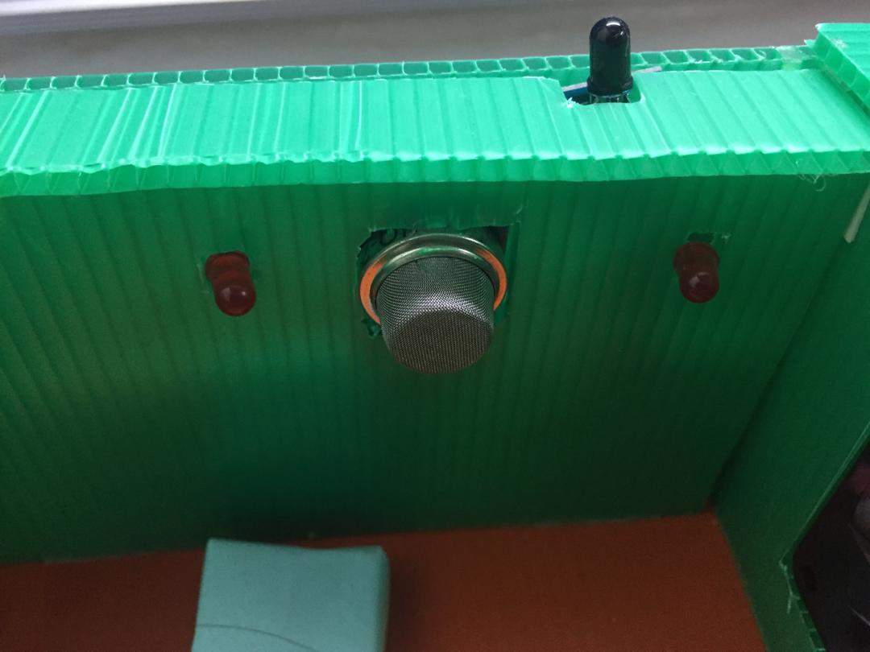 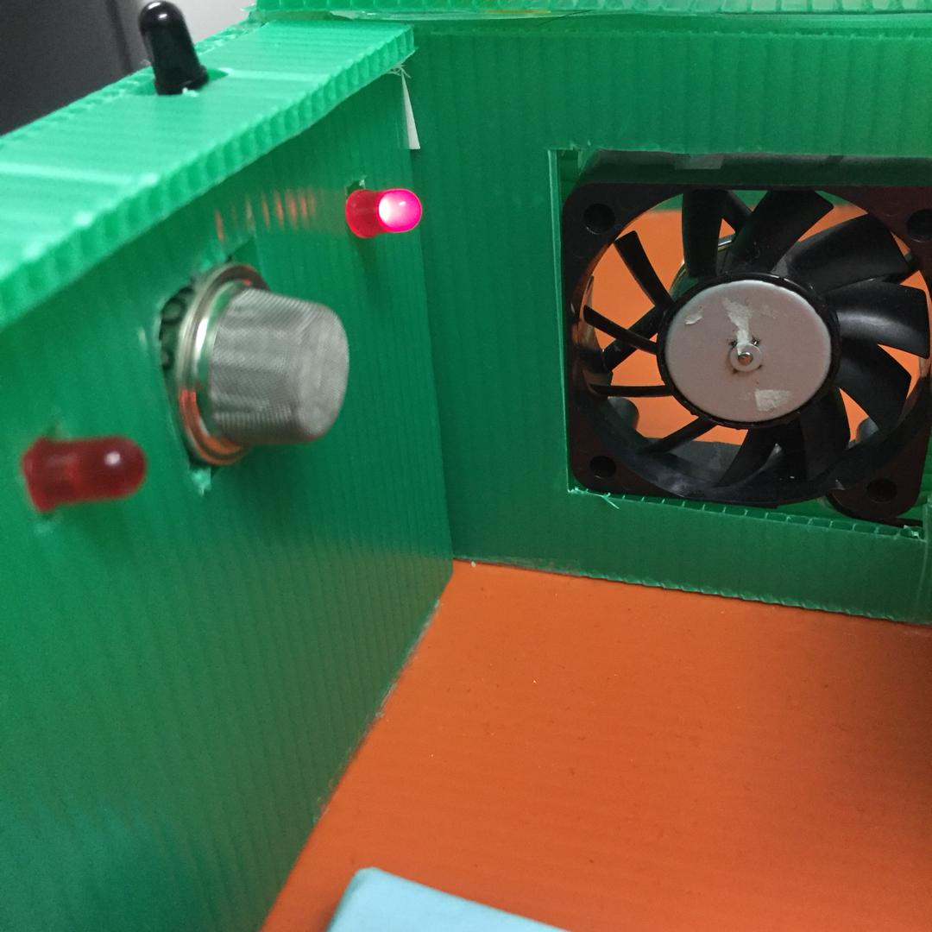 (a) (b)

Figure 3.9: Flame sensor (a) No flame detected (b) Flame detected

Figure 3.9 shows the flame sensor. When the flame sensor detects flame inside the kitchen, the LED will light up and alarm buzzer will be turned on to alert user and neighbour that the house is on fire so that they can take precautions action.

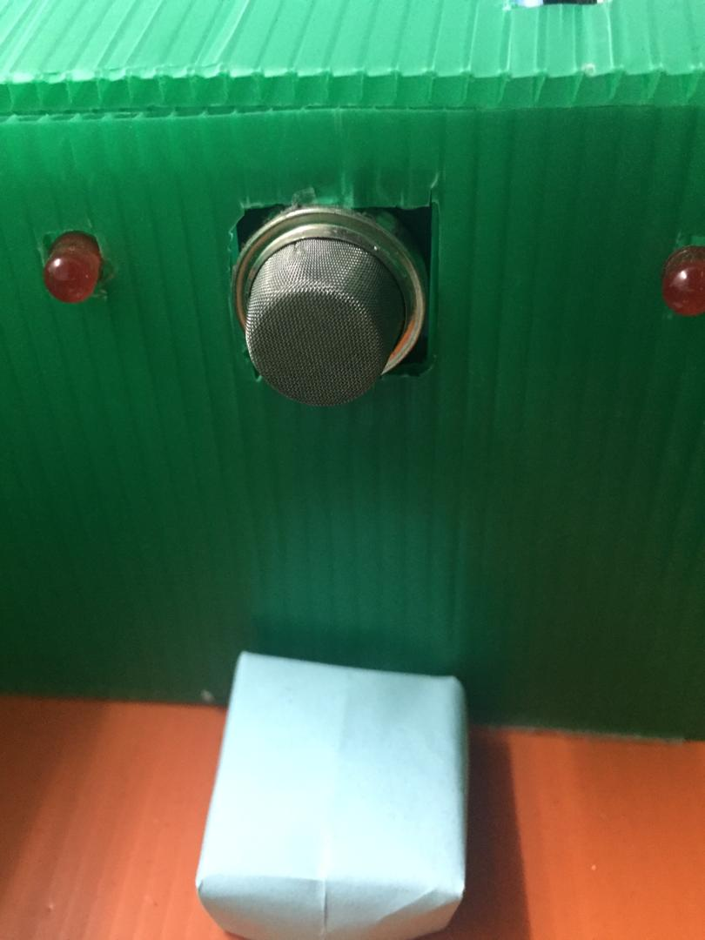 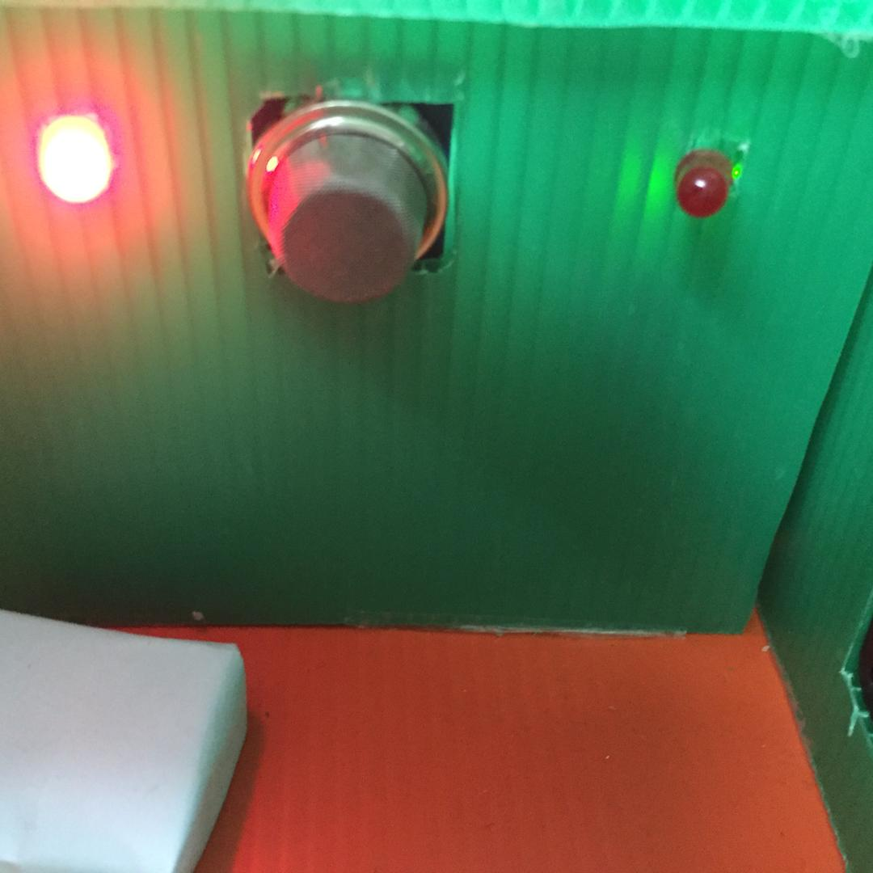 (a) (b)

1. (b)

Figure 3.10: Gas sensor (a) No gas detected (b) Gas detected

Figure 3.10 shows the gas sensor. When the gas sensor detects that existence of gas leaking inside the kitchen, the LED will light up and alarm buzzer will turn on to alert user and neighbour that there are leaking of gas inside the kitchen. Smoke and gas leaking are very dangerous to human as it can cause headaches or nausea. The symptoms become more severe with exposure to higher amounts of gas or long-term exposure. It can also cause an upset stomach, blurry vision, exhaustion, and dizziness [5].

**3.5 Smart House Monitoring in the Website**

This section shows the monitoring results of all sensors inside the smart house. Sensors will keep sending data to the Arduino and the database will be updated every 3 seconds for the current house status. All sensors information will be sent to the database and display into the webpage that has been built. This system will be easier for the user to monitor the current situation inside their house when they are away. The data on the website can be monitored as shown in the figure below.

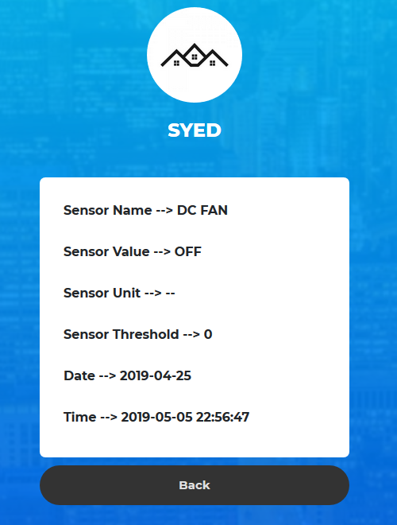 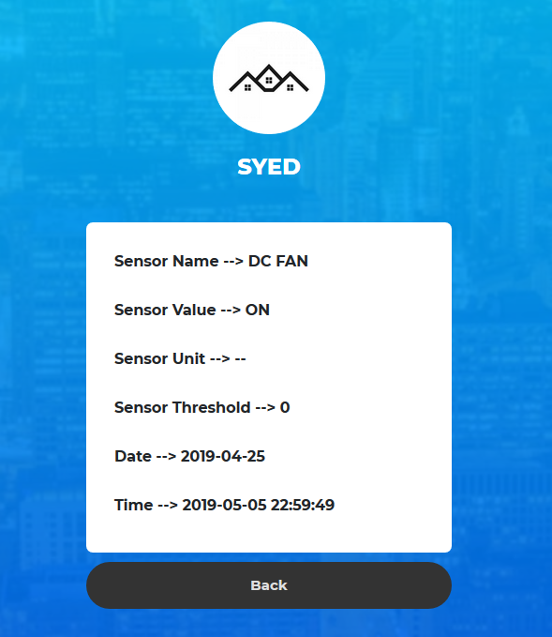

(a) (b)

Figure 3.11: Fan status (a) Fan off (b) Fan on

Figure 3.11 shows the detail of the DC fan from the webpage. User can check whether the fan is turned on or off. From the webpage, user can decide to turn on or off the fan by going to control section to control it.

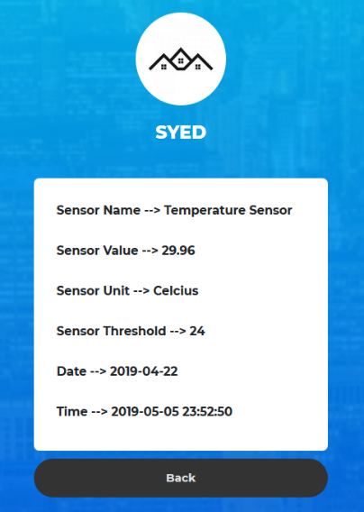

Figure 3.12: Temperature sensor detail

Figure 3.12 shows the value of the temperature sensor inside the bedroom 1. The temperature value will be updated to database every 3s and will display into the webpage.

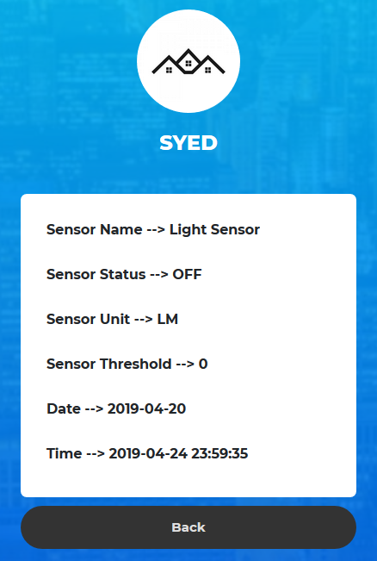 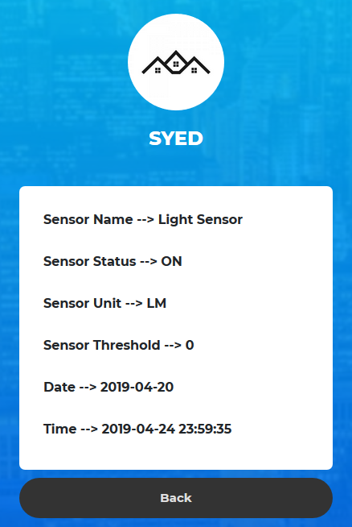

(a) (b)

Figure 3.13: Light status (a) Light off (b) Light on

Figure 3.13 shows the detail of the LDR sensor. From this website, the user can check the LED light status. From the sensor status, user check whether the LED light is ON or OFF. From this detail, user can take further action to turn ON or OFF the light from the control section.

y

Figure 3.14: Gas status (a) No gas detected (b) Gas detected

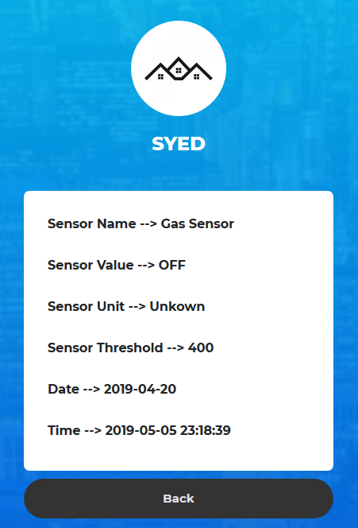 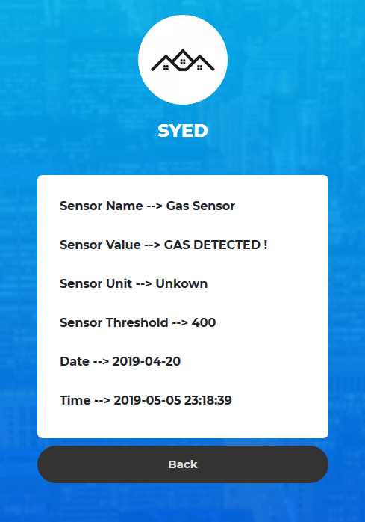

(a) (b)

Figure 3.14 shows the current status if gas sensor inside the house. User can check if there any gas leaking inside their house if they are far away. This sensor status will be updated every 3 seconds. Real-time update system is very important in order to inform user with latest situation inside their house because gas leaking is very dangerous since it could harm people health.

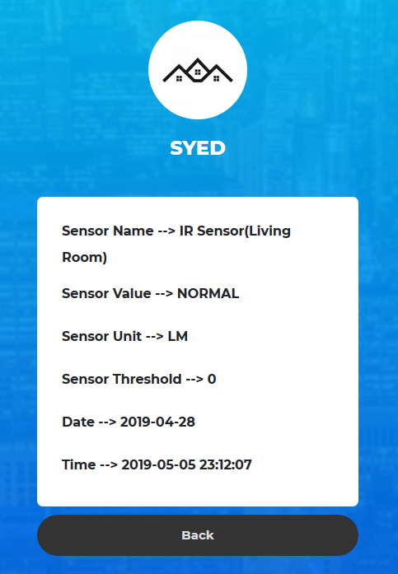 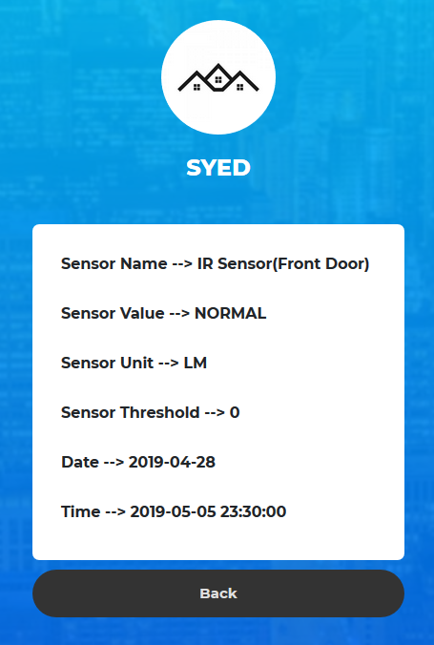 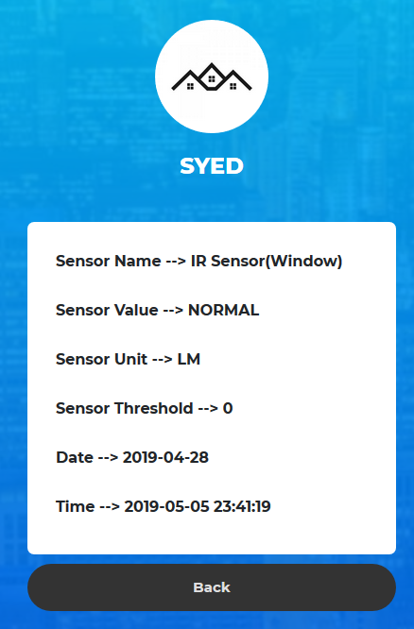

(a) (b) (c)

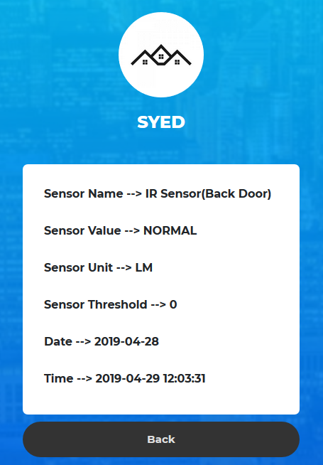

(d)

Figure 3.15: IR sensor status when there no intruder (a) Living room (b) Front Door (c)Window (d) Back door

Figure 3.15 shows the detail of the IR sensor in the living room, front door, window, and back door when there no intruder detected. The webpage will display “NORMAL” when there no intruder detected. IR sensor will be checked every 3 seconds, then the status will be sent to the database and display inside the webpage.

Figure 3.16: IR sensor status when intruder detected (a) Living room (b) Front Door (c) Window (d) Back door

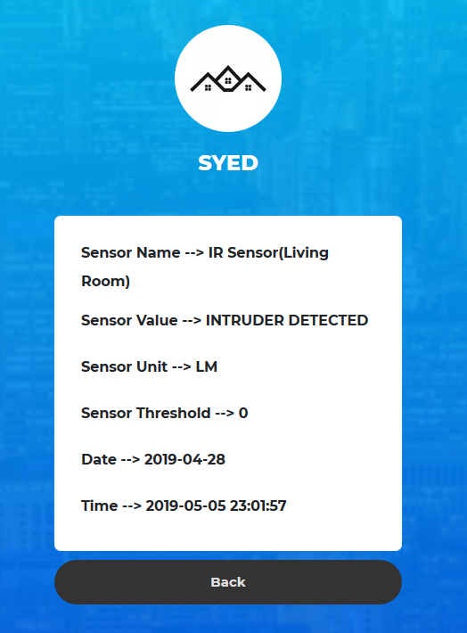 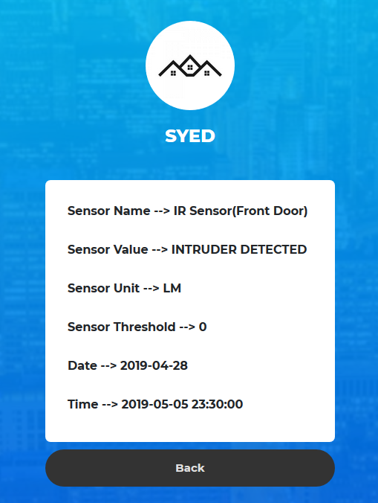 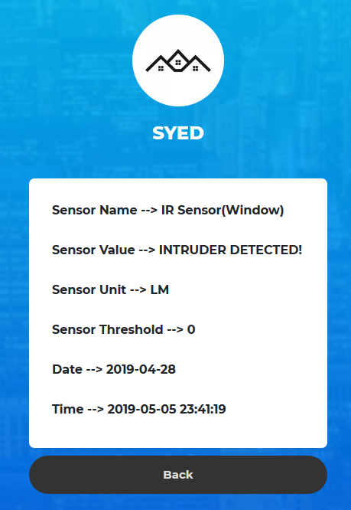

(a) (b) (c)

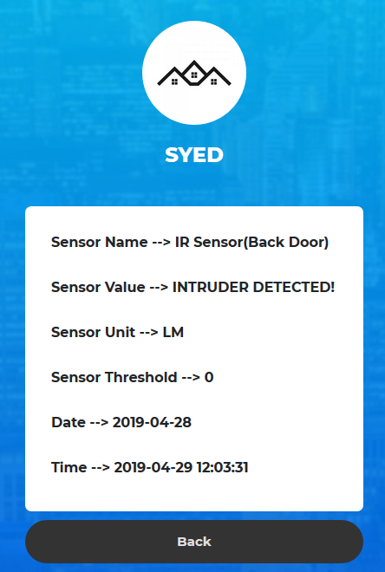

(d)

Figure 3.16 shows the detail of the IR sensor in the living room, front door, window, and back door when intruder is detected. The webpage will display “INTRUDER DETECTED” when there is intruder detected. IR sensor will be checked every 3 seconds, then the status will be sent to the database and display inside the webpage.

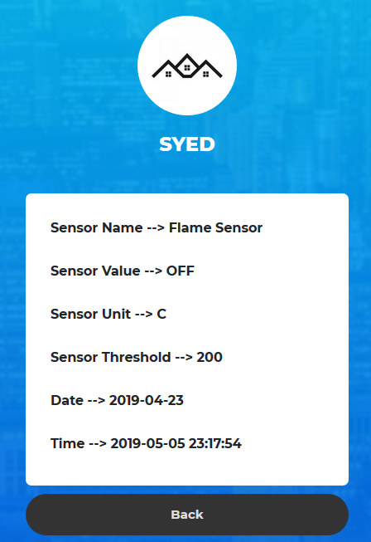 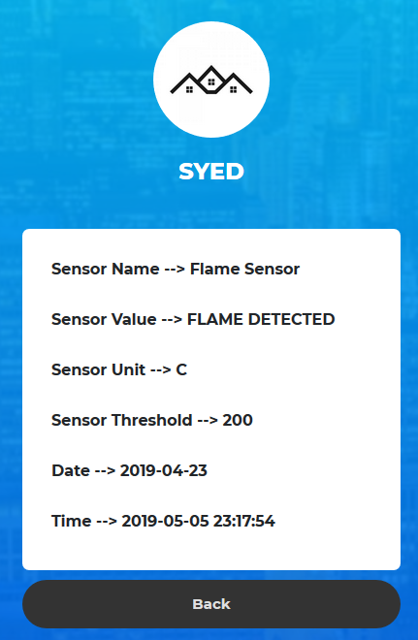

(a) (b)

Figure 3.17: Flame sensor status (a) No flame detected (b) flame detected

Figure 3.1 shows the status of the flame sensor. When the flame sensor detects fire, the database will be updated and display “OFF” or “FLAME DETECTED!” inside the webpage. When the fire was detected inside the kitchen, the webpage will display “FLAME DETECTED!”. In contrast, the webpage will display "OFF".

**3.6 Discussion**

The Arduino based smart home hub system is capable of providing better security in the sense that it can facilitate the detection of intruder when the intruder is trying to broke into the house. The system also can detect gas leaking and flame inside the kitchen in order to prevent toxic exposure and fire. Furthermore, the system also can check the temperature of the room. For example, if the temperature is above 25 ̊ C, the fan will automatically turn on to make sure the temperature of the room is livable and also to provide comfortable living condition to the household. Besides, the system can automatically turn on the light when the room becomes dark. The fan and light can also be controlled from the webpage. This function is implemented in order to reduce energy usage.

When IR sensor detects unusual heat and motion, the alarm buzzer and alarm light will turn on. IR sensor was installed near to the window, front door, back door, and middle of the living room because these places have high probability for the intruder to broke into the house. All data that are detected by the sensors will be sent to the database and display into the webpage every 3 seconds. Besides, the camera was installed in the middle of the living room to record any suspicious movement inside the house. In the kitchen area, gas sensor and the flame sensor were installed. With this sensor, the system can alert the owner if there any fire or gas leaking by turning on alarm buzzer and light and all the data will be sent to the database. Furthermore, inside the bedroom, light sensor and temperature sensor was installed. When the light sensor detects darkness, the LED will light up. Besides, when the temperature above 25 ̊ C fan will turn on in order to maintain the temperature inside the bedroom.

The project work was put up for studying and implementing by assembling the hardware, software and electrical part to controlling the system. The implement on Arduino board with ATmega2560 microcontroller was done. This was achieved by doing the assessments with this system. The progressive prototype has been shown at the result as a promising output. This system uses very low power, with less complexity in low cost manner so it can be implemented inside the house. After all, the entire system has been tested thoroughly in real-time and it is said to function successfully in helping people to monitor their house.

**CHAPTER 4**

**PROJECT DESIGN AND CONSIDERATION**

**4.1 Health and Safety**

When planning for the design of the Smart Home Hub, there are a number of aspects to consider in ensuring the safety and functionality of the design. First and foremost, health and safety should be given the highest consideration. Therefore, it is of a critical importance to only incorporate components and modules that are safe for the users in the design.

The main component of this project is Arduino board. In terms of the safety aspect, the Arduino board is labelled with the FCC and CE logo which indicate that they meet the electromagnetic compatibility standards set in their respective jurisdictions. Arduino/Genuine products meet the essential requirements of EU Directive 2001/95/CE General directive on products safety and 93/68/CE [6]. Therefore, the system is safe and not harmful to the users.

Furthermore, the design of this smart home will ensure the health and safety of the residence since it will be equipped with detection of specific incidents from happens such as flame and gas leaking detection in the kitchen by measuring the temperature in all rooms and detect any fire happens inside the house, as well as provide a secure home based security with movement detection and camera safety application by monitoring and tracking of the house through Arduino Camera and the website. If there is any intruder in front of Infrared Sensor (IR) inside the house, the buzzer will generate a warning signal. The IR sensor are placed at the front and back door and also at the window to detect any motion in the house. Lastly, the DC Fan is used to control the weather of the any room inside the house.

**4.2 Environmental Consideration**

In designing this project, our main focus is to help saving the energy since most of the appliance such as lighting, fan, air conditioning and other home appliances will be automatically turned off when the sensors reading is above certain threshold. Leaving lights on in unoccupied rooms is one of the biggest energy wasters in many homes. Hence, the sensing feature will automatically turn off the lights when residence forget to turn off the lights when they are away. In addition, the fire and gas leaking monitoring will surely help in preserving the environment.

The Smart Home Hub can help increasing energy efficiency by addressing such environmental concerns. It depends on how the residence use their smart home technology; it is possible to make their living space more energy efficient. For example, the home owners can have more precise control over the heating and cooling of their home with mobile applications that learns their temperature preferences. Lights can off automatically when the home owner leave the room, so they never have to worry about wasting energy.

**4.3 Cultural and Benefit to Society**

This project is designed by installing smart appliances such as a smart fan in smart home. Hence, residence can now use mobile applications to enjoy complete control of home’s functions from anywhere in the world. Residence can now be worry-free to leave their home when they forget to turn off their fan or air conditioner when they are away. With smart home, the residence can quickly and easily power off these appliances in seconds from the respective accompanying applications. This will avoid any dangerous incidents, and also help the residence to be worry-free while away from home.

**CHAPTER 5**

**PROJECT MANAGEMENT AND COSTING**

The grant chart of the whole project is shown in table 5.0 and task allocation completing the project shown in Table 5.1. Besides, Table 5.2 shows the project costing of the project.

**5.0 Project Gantt Chart**

**Table 5.0: The Gantt chart**

|  |  |  |  |  |  |  |  |  |  |  |  |  |  |  |  |  |  |  |  |
| --- | --- | --- | --- | --- | --- | --- | --- | --- | --- | --- | --- | --- | --- | --- | --- | --- | --- | --- | --- |
|  | **Week1** | **Week2** | **Week3** | **Week4** | **Week5** | **Week6** | **Week7** | **Week8** | **Week9** | **Week10** | **Week11** | **Week12** | **Week13** | **Week14** | **Week15** | **Week16** | **Week17** | **Week18** | **Week19** |
| **GDP Briefing**  Briefing by GDP coordinator and  Meeting with supervisor |  |  |  |  |  |  |  | Mid semester break |  |  |  |  |  |  |  |  |  |  |  |
| **Meeting with supervisor** Review  of project preparation software and hardware |  |  |  |  |  |  |  |  |  |  |  |  |  |  |  |  |  |  |
| **Introduction**  Background, Problem Statement, Objective and Scope of the Project |  |  |  |  |  |  |  |  |  |  |  |  |  |  |  |  |  |  |
| **Methodolog**y  Draw block diagram, schematic  Diagram and flow system |  |  |  |  |  |  |  |  |  |  |  |  |  |  |  |  |  |  |
| **Results and Discussion** Integrate  All the implemented system |  |  |  |  |  |  |  |  |  |  |  |  |  |  |  |  |  |  |
| **GDP Progress Assessments**  **(Supervisor**) |  |  |  |  |  |  |  |  |  |  |  |  |  |  |  |  |  |  |
| **GDP Presentation/VIVA** |  |  |  |  |  |  |  |  |  |  |  |  |  |  |  |  |  |  |
| **GDP Report Correction** |  |  |  |  |  |  |  |  |  |  |  |  |  |  |  |  |  |  |
| **Final Report Submission** |  |  |  |  |  |  |  |  |  |  |  |  |  |  |  |  |  |  |

**5.1 Task Allocation**

**Table 5.1: Report Task Allocation**

|  |  |  |  |  |  |
| --- | --- | --- | --- | --- | --- |
| **Tasks** | **Student’s Names** | | | | |
| **Syed** | **KarhLorh** | **Nurul Atikah** | **Hassankafi** | **Siti** |
| **1.Introduction** |  | | | | |
| Background |  |  |  |  |  |
| Problem statement |  |  |  |  |  |
| Objectives |  |  |  |  |  |
| Scope of the Project |  |  |  |  |  |
| **2.Methodology** |  |  |  |  |  |
| Design complexity |  |  |  |  |  |
| Design flow and process |  |  |  |  |  |
| **3.Results and Discussion** |  |  |  |  |  |
| Result: Graph, Chart, Data, Discussion |  |  |  |  |  |
| **4.Project Design Consideration** |  | | | | |
| Health consideration |  |  |  |  |  |
| Safety Consideration |  |  |  |  |  |
| Environment Consideration |  |  |  |  |  |
| Cultural and Benefit to the society |  |  |  |  |  |
| **5.Project Management and Costing** |  | | | | |
| Project Gantt Chart |  |  |  |  |  |
| Task Allocation |  |  |  |  |  |
| Project Costing |  |  |  |  |  |
| **6.Conclusion and recommendation** |  | | | | |
| Conclusion |  |  |  |  |  |
| Recommendation |  |  |  |  |  |

**Table 5.2: Project Task Allocation**

|  |  |  |  |  |  |
| --- | --- | --- | --- | --- | --- |
| **Tasks** | **Student’s Names** | | | | |
| **Syed** | **KarhLorh** | **Nurul Atikah** | **Hassankafi** | **Siti** |
| **1.Hardware** |  | | | | |
| Infrared Sensor |  |  |  |  |  |
| Flame Sensor |  |  |  |  |  |
| Light Sensor |  |  |  |  |  |
| Temperature Sensor |  |  |  |  |  |
| Camera OV7670 |  |  |  |  |  |
| LCD Display |  |  |  |  |  |
| Gas Sensor (MQ2) |  |  |  |  |  |
| DC fan |  |  |  |  |  |
| **2.Software** |  | | | | |
| Website |  |  |  |  |  |
| Digital Ocean Server |  |  |  |  |  |
| PhpMyAdmin |  |  |  |  |  |

**5.2 Project Costing**

**Table 5.3 Project Costing**

|  |  |  |  |  |  |
| --- | --- | --- | --- | --- | --- |
| **No** | **Component** | **Quantify** | **Shipping fee(RM)** | **Price(Rm)** | **Total(RM)** |
| 1 | Arduino Mega | 1 |  | 45.00 | 45.00 |
| 2 | Infrared Sensor Module | 4 |  | 5.00 | 20.00 |
| 3 | Flame Sensor Module | 4 |  | 5.00 | 20.00 |
| 4 | Light Sensor Module | 2 |  | 5.00 | 10.00 |
| 5 | NodeMCUwemos | 1 |  | 16.00 | 16.00 |
| 6 | LED Green | 5 |  | 0.03 | 0.15 |
| 7 | LED Red | 5 |  | 0.10 | 0.5 |
| 8 | 40 Ways Female to Female Jumper Wire | 1 |  | 3.00 | 3.00 |
| 9 | 40 Ways Male to Female Jumper Wire | 1 |  | 3.00 | 3.00 |
| 10 | 40 Ways Male to Male Jumper Wire | 1 |  | 3.00 | 3.00 |
| 11 | Gas Sensor (MQ2) | 1 |  | 10.00 | 10.00 |
| 12 | Temperature Sensor module | 1 |  | 5.00 | 5.00 |
| 13 | Card Board-27inch | 3 |  | 8.90 | 26.7 |
| 14 | Ice Stick (Big) | 1 |  | 3.90 | 3.90 |
| 15 | Ice Stick (small) | 1 |  | 3.90 | 3.90 |
| 16 | Stick | 1 |  | 3.90 | 3.90 |
| 17 | Arduino UNO | 1 |  | 32.00 | 32.00 |
| 18 | 9v Battery | 2 |  | 13.90 | 27.80 |
| 19 | LCD Display | 1 |  | 8.00 | 8.00 |
| 20 | Camera OV7670 | 1 |  | 44.30 | 44.30 |
| 21 | DC fan | 1 |  | 12.89 | 12.90 |
|  |  |  | Total fee |  | 299.05 |

**CHAPTER 6**

**CONCLUSION AND RECOMMEDATION**

**6.0 Conclusion**

The project has proposed the idea of smart homes that can support a lot of home automation systems. A smart home contains a connection between wireless communication, sensors, monitoring and tracking. Smart homes are a huge system that includes multiple technologies and applications that can be used to provide security and control of the home easily. This project discussed the designed modules like sensors' circuits, monitoring and tracking of the home through IP camera and the websites.

A series of experiments have been carried out on the proposed smart home. These experiments show how to detect the fire, to detect smoke or gas leak. Also, how to detect any intruder to the home, detect and control the weather of the any room and how to secure the home through an access code. Also, this project showed the idea of measuring the temperature in all rooms and detect any fire happens and to detect any motion in the home by using infrared sensors. Central control for the entire home has been designed using Arduino MEGA system designs. These designs were for access control to the home, temperature validation, and control board system to connect all the security and control circuits together.

This project is providing a safe and secured smart home to the system owner. The owner can easily monitor the activity that happen in the home by using the website. The owner also can easily control the sensor and electrical appliance such as fan using the website.

**6.1 Recommendation**

The system is localized in the home where the family safety is being the first priority. The system is to aim for a safer house, there are some recommendations for future works. Some of them are:

• The house needs to be installed with more movement sensor so that the house will be fully covered by the sensor.

• The houses also need to be install with IP camera system for a better video quality.

**REFERENCES**

[1] Cutting edge: IT's guide to edge data centers.smart home or building (home automation or domotics), July 2018.[Online].Available:<https://internetofthingsagenda>.

techtarget.com/definition/smart-home-or-building.[Accessed April 1 2019]

[2] Jackie Craven. Exploring Home Automation and Domotics,February 19, 2019. [Online].Available:[https://www.thoughtco.com/what-is-a-smart-house-domotics- 177572](https://www.thoughtco.com/what-is-a-smart-house-domotics-%09177572)[Accessed April 1 2019]

[3] Marty Ahrens."Home Structure Fires”. Report of National Fires Protection Association (NFPA),December 2018. [Online]. Available: https://www.nfpa. org/News-and- Research/Data-research-and-tools/Building-and-Life-Safety/Home- Structure-Fires.[Accessed April 19 2019]

[4] Department of Statistic Malaysia. “Crime Statistics, Malaysia, 2018”. Friday 28, December 2018 1200. [Online]. Available: [https://www.dosm.gov.my/v1/index.php ?r=](https://www.dosm.gov.my/v1/index.php%20%09?r=)column/cthemeByCat&cat=455&bul_id=SnJlWjNGZ3VWajUraDlBcFpM Q3JWUT09& menu_id=U3VPMldoYUxzVzFaYmNkWXZteGduZz09.

[Accessed April 19 2019]

[5] Jayne Leonard. How to recognize a gas leak, Wednesday 21 March 2018.

[Online]. Available: <https://www.medicalnewstoday.com/articles/321277.php>.

[Accessed May 5 2019]

[6] Arduino/Genuino Products Warranty, 2019. [Online]. Available: https://www.arduino.cc/en/main/warranty. [Accessed May1 2019]

[7] JithinSanal. Arduino project hub May 12 2018[Online].Available: https://create.ardu ino.cc/projecthub/jithinsanal1610/home-automation-using-arduino-arduino-diy-proje ct-6c03ba [Accessed April 25 2019]

**APPENDICES**

**1. Arduino MEGA**

#include <SoftwareSerial.h>

#include <ArduinoJson.h>

#define arraySize 32

#include <LCD.h>

#include <LiquidCrystal.h>

#include <LiquidCrystal_I2C.h>

#include <Wire.h>

LiquidCrystal_I2C lcd(0x27, 2, 1, 0, 4, 5, 6, 7, 3, POSITIVE);

char inData[arraySize];

char y[arraySize];

void sendValues(String tsdf);

SoftwareSerial NodeMCU(11,12);

int response;

int ldr_pin0 = 23;

int ldrled_pin0 = 25;

int flamesensvalue0 = 0;

int flame_pin0 = A2;

int fled_pin0 = 28;

int threshold0 = 200;

int buzpin = 48;

int buzpin1 = 47;

int ir_pin0 = 22;

int irled_pin0 = 24;

int ir_pin1 = 52;

int irled_pin1 = 53;

int ir_pin2 = 50;

int irled_pin2 = 51;

int ir_pin3 = 26;

int irled_pin3 = 27;

int iro0 = HIGH;

int iro1 = HIGH;

int iro2 = HIGH;

int iro3 = HIGH;

int smoke = A1;

int sensorThres0 = 400;

int smrled_pin0 = 29;

int Vo;

float R1 = 2252;

float logR2, R2, T;

float A = 1.484778004e-03, B = 2.348962910e-04, C = 1.006037158e-07;

int ThermistorPin = A0;

int fan = 49;

int buzz;

int a_light;

int control = 1;

void setup() {

pinMode(ldr_pin0,INPUT);

pinMode(flame_pin0,INPUT);

pinMode(fled_pin0,OUTPUT);

pinMode(ldr_pin0,INPUT);

pinMode(ldrled_pin0,OUTPUT);

pinMode(ir_pin0,INPUT);

pinMode(irled_pin0,OUTPUT);

pinMode(ir_pin1,INPUT);

pinMode(irled_pin1,OUTPUT);

pinMode(ir_pin2,INPUT);

pinMode(irled_pin2,OUTPUT);

pinMode(ir_pin3,INPUT);

pinMode(irled_pin3,OUTPUT);

pinMode(smoke,INPUT);

pinMode(smrled_pin0,OUTPUT);

pinMode(buzpin,OUTPUT);

pinMode(buzpin1,OUTPUT);

pinMode(fan,OUTPUT);

digitalWrite(fan,HIGH);

Serial.begin(9600);

NodeMCU.begin(9600);

Serial.println("setup");

lcd.begin(16,2);

lcd.backlight();

}

void loop() {

lcd.setCursor(2,0);

lcd.print("TEMPERATURE:");

TEMP();

lcd.setCursor(5,1);

lcd.print(T);

lcd.print((char)223);

lcd.print("C");

delay(3000);

Serial.println("loop");

float temp = TEMP();

int ldr = LDR(control);

int flame = FLAME();

int ir = IR();

int ir1 = IR1();

int ir2 = IR2();

int ir3 = IR3();

int smoke = SMOKE();

int fan = FAN(control);

if(buzpin == HIGH){

buzz = 1;

}else{

buzz = 0;

}

if(fled_pin0 == HIGH){

a_light = 1;

}else{

a_light = 0;

}

Serial.println(buzz);

Serial.println(a_light);

Serial.print("light ");

Serial.println(ldr);

Serial.print("flame ");

Serial.println(flame);

control = sendValues(ldr,flame,ir,ir1,ir2,ir3,smoke,temp,fan,buzz,a_light);

Serial.println("control");

Serial.println(control);

}

int sendValues(int ldr2,int flame2,int ir, int ir1, int ir2, int ir3, int smoke, float temp, int fan, int buzz, int a_light){

StaticJsonBuffer<1000> jsonBuffer;

JsonObject& root = jsonBuffer.createObject();

root["order"] = "send_values";

root["ldr"] = ldr2;

root["flame"] = flame2;

root["ir"] = ir;

root["ir2"] = ir1;

root["ir3"] = ir2;

root["ir4"] = ir3;

root["smoke"] = smoke;

root["temp"] = temp;

root["fan"] = fan;

root["buzz"] = buzz;

root["light"] = a_light;

root.printTo(NodeMCU);

Serial.println("Data Sent ...");

if(NodeMCU.available()){

Serial.println("Response available ...");

}

response = NodeMCU.parseInt();

Serial.println(response);

if(response==1){

Serial.println("fan and light is off");

}

else if(response==2){

Serial.println("fan off and light on");

}

else if(response==3){

Serial.println("fan on and light off");

}

else if(response==4){

Serial.println("fan on and light on");

}

else{

Serial.println("Error occur");

}

return response;

}

int LDR(int ctrl){

int value;

if( digitalRead(ldr_pin0) == 1 || ctrl == 2 || ctrl == 4 || ctrl > 4){

digitalWrite(ldrled_pin0, HIGH);

value = 1;

}else if(ctrl == 0){

digitalWrite(ldrled_pin0, HIGH);

value = 1;

}

else{

digitalWrite(ldrled_pin0, LOW);

value = 0;

}

delay(10);

return value;

}

int FLAME(){

int value;

flamesensvalue0 = analogRead(flame_pin0);

if(flamesensvalue0 <= threshold0)

{

digitalWrite(fled_pin0,HIGH);

tone(buzpin,1000);

value = 1;

}

else

{

digitalWrite(fled_pin0,LOW);

noTone(buzpin);

value = 0;

}

delay(10);

return value;

}

int IR(){

int value;

iro0 = digitalRead(ir_pin0);

if(iro0 == LOW)

{

digitalWrite(irled_pin0, HIGH);

tone(buzpin1,1000);

value = 1;

}

else

{

digitalWrite(irled_pin0, LOW);

noTone(buzpin1);

value = 0;

}

delay(10);

return value;

}

int IR1(){

int value;

iro1 = digitalRead(ir_pin1);

tone(buzpin1,1000);

if(iro1 == LOW)

{

digitalWrite(irled_pin1, HIGH);

value = 1;

}

else

{

digitalWrite(irled_pin1, LOW);

value = 0;

}

delay(10);

return value;

}

int IR2(){

int value;

iro2 = digitalRead(ir_pin2);

if(iro2 == LOW)

{

digitalWrite(irled_pin2, HIGH);

// tone(buzpin1,1000);

value = 1;

}

else

{

digitalWrite(irled_pin2, LOW);

value = 0;

}

delay(10);

return value;

}

int IR3(){

int value;

iro3 = digitalRead(ir_pin3);

if(iro3 == LOW)

{

digitalWrite(irled_pin3, HIGH);

// tone(buzpin1,1000);

value = 1;

}

else

{

digitalWrite(irled_pin3, LOW);

value = 0;

}

delay(10);

return value;

}

int SMOKE(){

int analogSensor = analogRead(smoke);

int value;

if(analogSensor > sensorThres0)

{

digitalWrite(smrled_pin0,HIGH);

tone(buzpin,1000);

value=1;

}

else

{

digitalWrite(smrled_pin0,LOW);

noTone(buzpin);

value=0;

}

delay(10);

return value;

}

float TEMP()

{

Vo = analogRead(ThermistorPin);

R2 = R1* (1023.0 / (float)Vo - 1.0);

logR2 = log(R2);

T = (1.0 / (A + B*logR2 + C*logR2*logR2*logR2));

T = -(T + 265.15 - 589);

return T;

}

int FAN(int ctrl){

int value;

if(T>26.19 || ctrl == 3 || ctrl == 4)

{

digitalWrite(fan,LOW);

value = 1;

}else if(T>26.19 && (ctrl == 1 || ctrl == 2)){

digitalWrite(fan,HIGH);

value = 0;

}

else if(ctrl == 0){

digitalWrite(fan,HIGH);

value = 0;

}

else

{

digitalWrite(fan,HIGH);

value = 0;

}

return value;

}

**2. NodeMCU**

#include <SoftwareSerial.h>

#include <ESP8266WiFi.h>

#include <ESP8266WiFiMulti.h>

#include <ESP8266HTTPClient.h>

#include <WiFiClient.h>

#include <ArduinoJson.h>

void check_user(String user_id);

//String result;

String payload;

HTTPClient http;

WiFiClient client;

SoftwareSerial ArduinoUno(D2,D3);

ESP8266WiFiMulti WiFiMulti;

void setup() {

// Initialize Serial port

Serial.begin(9600);

ArduinoUno.begin(9600);

while (!Serial) continue;

for (uint8_t t = 4; t > 0; t--) {

Serial.printf("[SETUP] WAIT %d...\n", t);

Serial.flush();

delay(1000);

}

WiFi.mode(WIFI_STA);

WiFiMulti.addAP("Nova 4", "karhlorh1028");

}

void loop() {

StaticJsonBuffer<1000> jsonBuffer;

JsonObject& root = jsonBuffer.parseObject(ArduinoUno);

if (root == JsonObject::invalid())

return;

String data1=root["order"];

if(data1 == "send_values"){

int data1=root["ldr"];

int data2=root["flame"];

int data3=root["ir"];

int data4=root["ir2"];

int data5=root["ir3"];

int data6=root["ir4"];

int data7=root["smoke"];

float data8=root["temp"];

int data9=root["fan"];

int data10=root["buzz"];

int data11=root["light"];

Serial.println(data10);

check_fan();

check_user(data1,data2,data3,data4,data5,data6,data7,data8,data9,data10,data11);

}

}

void check_fan(){

// wait for WiFi connection

if ((WiFiMulti.run() == WL_CONNECTED)) {

Serial.println("Wifi Connected");

// HTTPClient http; // Causes one time response

Serial.print("[HTTP] begin...\n");

if (http.begin(client, "http://157.230.245.56/syed/dummy/check_fan.php")) {

Serial.print("[HTTP] GET...\n");

// start connection and send HTTP header

int httpCode = http.GET();

// httpCode will be negative on error

if (httpCode > 0) {

// HTTP header has been send and Server response header has been handled

Serial.printf("[HTTP] GET... code: %d\n", httpCode);

// file found at server

if (httpCode == HTTP_CODE_OK || httpCode == HTTP_CODE_MOVED_PERMANENTLY) {

payload = http.getString();

Serial.println(payload);

ArduinoUno.println(payload);

Serial.println();

}

} else {

Serial.printf("[HTTP] GET... failed, error: %s\n", http.errorToString(httpCode).c_str());

}

http.end();

} else {

Serial.printf("[HTTP} Unable to connect\n");

}

}

}

void check_user(int ldr, int flame, int ir, int ir2, int ir3, int ir4, int smoke, float temp, int fan, int buzz, int light){

// wait for WiFi connection

if ((WiFiMulti.run() == WL_CONNECTED)) {

Serial.println("Wifi Connected");

// HTTPClient http; // Causes one time response

Serial.print("[HTTP] begin...\n");

if (http.begin(client, "http://157.230.245.56/syed/SmartHouse/accept.php?flame=" + String(flame) + "&light=" + String(ldr) + "&ir1=" + String(ir) + "&ir2=" + String(ir2) + "&ir3=" + String(ir3) + "&ir4=" + String(ir4) + "&smoke=" + String(smoke) + "&temp=" + String(temp) + "&fan=" + String(fan) + "&buzz=" + String(buzz) + "&light=" + String(light)))

{

Serial.print("[HTTP] GET...\n");

// start connection and send HTTP header

int httpCode = http.GET();

// httpCode will be negative on error

if (httpCode > 0) {

// HTTP header has been send and Server response header has been handled

Serial.printf("[HTTP] GET... code: %d\n", httpCode);

// file found at server

if (httpCode == HTTP_CODE_OK || httpCode == HTTP_CODE_MOVED_PERMANENTLY) {

payload = http.getString();

Serial.println(payload);

}

} else {

Serial.printf("[HTTP] GET... failed, error: %s\n", http.errorToString(httpCode).c_str());

}

http.end();

} else {

Serial.printf("[HTTP} Unable to connect\n");

}

}}

**3. Arduino Uno**

#include <stdint.h>

#include <avr/io.h>

#include <util/twi.h>

#include <util/delay.h>

#include <avr/pgmspace.h>

#define F_CPU 16000000UL

#define vga 0

#define qvga 1

#define qqvga 2

#define yuv422 0

#define rgb565 1

#define bayerRGB 2

#define camAddr_WR 0x42

#define camAddr_RD 0x43

/* Registers */

#define REG_GAIN 0x00 /* Gain lower 8 bits (rest in vref) */

#define REG_BLUE 0x01 /* blue gain */

#define REG_RED 0x02 /* red gain */

#define REG_VREF 0x03 /* Pieces of GAIN, VSTART, VSTOP */

#define REG_COM1 0x04 /* Control 1 */

#define COM1_CCIR656 0x40 /* CCIR656 enable */

#define REG_BAVE 0x05 /* U/B Average level */

#define REG_GbAVE 0x06 /* Y/Gb Average level */

#define REG_AECHH 0x07 /* AEC MS 5 bits */

#define REG_RAVE 0x08 /* V/R Average level */

#define REG_COM2 0x09 /* Control 2 */

#define COM2_SSLEEP 0x10 /* Soft sleep mode */

#define REG_PID 0x0a /* Product ID MSB */

#define REG_VER 0x0b /* Product ID LSB */

#define REG_COM3 0x0c /* Control 3 */

#define COM3_SWAP 0x40 /* Byte swap */

#define COM3_SCALEEN 0x08 /* Enable scaling */

#define COM3_DCWEN 0x04 /* Enable downsamp/crop/window */

#define REG_COM4 0x0d /* Control 4 */

#define REG_COM5 0x0e /* All "reserved" */

#define REG_COM6 0x0f /* Control 6 */

#define REG_AECH 0x10 /* More bits of AEC value */

#define REG_CLKRC 0x11 /* Clocl control */

#define CLK_EXT 0x40 /* Use external clock directly */

#define CLK_SCALE 0x3f /* Mask for internal clock scale */

#define REG_COM7 0x12 /* Control 7 */ //REG mean address.

#define COM7_RESET 0x80 /* Register reset */

#define COM7_FMT_MASK 0x38

#define COM7_FMT_VGA 0x00

#define COM7_FMT_CIF 0x20 /* CIF format */

#define COM7_FMT_QVGA 0x10 /* QVGA format */

#define COM7_FMT_QCIF 0x08 /* QCIF format */

#define COM7_RGB 0x04 /* bits 0 and 2 - RGB format */

#define COM7_YUV 0x00 /* YUV */

#define COM7_BAYER 0x01 /* Bayer format */

#define COM7_PBAYER 0x05 /* "Processed bayer" */

#define REG_COM8 0x13 /* Control 8 */

#define COM8_FASTAEC 0x80 /* Enable fast AGC/AEC */

#define COM8_AECSTEP 0x40 /* Unlimited AEC step size */

#define COM8_BFILT 0x20 /* Band filter enable */

#define COM8_AGC 0x04 /* Auto gain enable */

#define COM8_AWB 0x02 /* White balance enable */

#define COM8_AEC 0x01 /* Auto exposure enable */

#define REG_COM9 0x14 /* Control 9- gain ceiling */

#define REG_COM10 0x15 /* Control 10 */

#define COM10_HSYNC 0x40 /* HSYNC instead of HREF */

#define COM10_PCLK_HB 0x20 /* Suppress PCLK on horiz blank */

#define COM10_HREF_REV 0x08 /* Reverse HREF */

#define COM10_VS_LEAD 0x04 /* VSYNC on clock leading edge */

#define COM10_VS_NEG 0x02 /* VSYNC negative */

#define COM10_HS_NEG 0x01 /* HSYNC negative */

#define REG_HSTART 0x17 /* Horiz start high bits */

#define REG_HSTOP 0x18 /* Horiz stop high bits */

#define REG_VSTART 0x19 /* Vert start high bits */

#define REG_VSTOP 0x1a /* Vert stop high bits */

#define REG_PSHFT 0x1b /* Pixel delay after HREF */

#define REG_MIDH 0x1c /* Manuf. ID high */

#define REG_MIDL 0x1d /* Manuf. ID low */

#define REG_MVFP 0x1e /* Mirror / vflip */

#define MVFP_MIRROR 0x20 /* Mirror image */

#define MVFP_FLIP 0x10 /* Vertical flip */

#define REG_AEW 0x24 /* AGC upper limit */

#define REG_AEB 0x25 /* AGC lower limit */

#define REG_VPT 0x26 /* AGC/AEC fast mode op region */

#define REG_HSYST 0x30 /* HSYNC rising edge delay */

#define REG_HSYEN 0x31 /* HSYNC falling edge delay */

#define REG_HREF 0x32 /* HREF pieces */

#define REG_TSLB 0x3a /* lots of stuff */

#define TSLB_YLAST 0x04 /* UYVY or VYUY - see com13 */

#define REG_COM11 0x3b /* Control 11 */

#define COM11_NIGHT 0x80 /* NIght mode enable */

#define COM11_NMFR 0x60 /* Two bit NM frame rate */

#define COM11_HZAUTO 0x10 /* Auto detect 50/60 Hz */

#define COM11_50HZ 0x08 /* Manual 50Hz select */

#define COM11_EXP 0x02

#define REG_COM12 0x3c /* Control 12 */

#define COM12_HREF 0x80 /* HREF always */

#define REG_COM13 0x3d /* Control 13 */

#define COM13_GAMMA 0x80 /* Gamma enable */

#define COM13_UVSAT 0x40 /* UV saturation auto adjustment */

#define COM13_UVSWAP 0x01 /* V before U - w/TSLB */

#define REG_COM14 0x3e /* Control 14 */

#define COM14_DCWEN 0x10 /* DCW/PCLK-scale enable */

#define REG_EDGE 0x3f /* Edge enhancement factor */

#define REG_COM15 0x40 /* Control 15 */

#define COM15_R10F0 0x00 /* Data range 10 to F0 */

#define COM15_R01FE 0x80 /* 01 to FE */

#define COM15_R00FF 0xc0 /* 00 to FF */

#define COM15_RGB565 0x10 /* RGB565 output */

#define COM15_RGB555 0x30 /* RGB555 output */

#define REG_COM16 0x41 /* Control 16 */

#define COM16_AWBGAIN 0x08 /* AWB gain enable */

#define REG_COM17 0x42 /* Control 17 */

#define COM17_AECWIN 0xc0 /* AEC window - must match COM4 */

#define COM17_CBAR 0x08 /* DSP Color bar */

/*

* This matrix defines how the colors are generated, must be

* tweaked to adjust hue and saturation.

*

* Order: v-red, v-green, v-blue, u-red, u-green, u-blue

* They are nine-bit signed quantities, with the sign bit

* stored in0x58.Sign for v-red is bit 0, and up from there.

*/

#define REG_CMATRIX_BASE 0x4f

#define CMATRIX_LEN 6

#define REG_CMATRIX_SIGN 0x58

#define REG_BRIGHT 0x55 /* Brightness */

#define REG_CONTRAS 0x56 /* Contrast control */

#define REG_GFIX 0x69 /* Fix gain control */

#define REG_REG76 0x76 /* OV's name */

#define R76_BLKPCOR 0x80 /* Black pixel correction enable */

#define R76_WHTPCOR 0x40 /* White pixel correction enable */

#define REG_RGB444 0x8c /* RGB 444 control */

#define R444_ENABLE 0x02 /* Turn on RGB444, overrides 5x5 */

#define R444_RGBX 0x01 /* Empty nibble at end */

#define REG_HAECC1 0x9f /* Hist AEC/AGC control 1 */

#define REG_HAECC2 0xa0 /* Hist AEC/AGC control 2 */

#define REG_BD50MAX 0xa5 /* 50hz banding step limit */

#define REG_HAECC3 0xa6 /* Hist AEC/AGC control 3 */

#define REG_HAECC4 0xa7 /* Hist AEC/AGC control 4 */

#define REG_HAECC5 0xa8 /* Hist AEC/AGC control 5 */

#define REG_HAECC6 0xa9 /* Hist AEC/AGC control 6 */

#define REG_HAECC7 0xaa /* Hist AEC/AGC control 7 */

#define REG_BD60MAX 0xab /* 60hz banding step limit */

#define REG_GAIN 0x00 /* Gain lower 8 bits (rest in vref) */

#define REG_BLUE 0x01 /* blue gain */

#define REG_RED 0x02 /* red gain */

#define REG_VREF 0x03 /* Pieces of GAIN, VSTART, VSTOP */

#define REG_COM1 0x04 /* Control 1 */

#define COM1_CCIR656 0x40 /* CCIR656 enable */

#define REG_BAVE 0x05 /* U/B Average level */

#define REG_GbAVE 0x06 /* Y/Gb Average level */

#define REG_AECHH 0x07 /* AEC MS 5 bits */

#define REG_RAVE 0x08 /* V/R Average level */

#define REG_COM2 0x09 /* Control 2 */

#define COM2_SSLEEP 0x10 /* Soft sleep mode */

#define REG_PID 0x0a /* Product ID MSB */

#define REG_VER 0x0b /* Product ID LSB */

#define REG_COM3 0x0c /* Control 3 */

#define COM3_SWAP 0x40 /* Byte swap */

#define COM3_SCALEEN 0x08 /* Enable scaling */

#define COM3_DCWEN 0x04 /* Enable downsamp/crop/window */

#define REG_COM4 0x0d /* Control 4 */

#define REG_COM5 0x0e /* All "reserved" */

#define REG_COM6 0x0f /* Control 6 */

#define REG_AECH 0x10 /* More bits of AEC value */

#define REG_CLKRC 0x11 /* Clocl control */

#define CLK_EXT 0x40 /* Use external clock directly */

#define CLK_SCALE 0x3f /* Mask for internal clock scale */

#define REG_COM7 0x12 /* Control 7 */

#define COM7_RESET 0x80 /* Register reset */

#define COM7_FMT_MASK 0x38

#define COM7_FMT_VGA 0x00

#define COM7_FMT_CIF 0x20 /* CIF format */

#define COM7_FMT_QVGA 0x10 /* QVGA format */

#define COM7_FMT_QCIF 0x08 /* QCIF format */

#define COM7_RGB 0x04 /* bits 0 and 2 - RGB format */

#define COM7_YUV 0x00 /* YUV */

#define COM7_BAYER 0x01 /* Bayer format */

#define COM7_PBAYER 0x05 /* "Processed bayer" */

#define REG_COM8 0x13 /* Control 8 */

#define COM8_FASTAEC 0x80 /* Enable fast AGC/AEC */

#define COM8_AECSTEP 0x40 /* Unlimited AEC step size */

#define COM8_BFILT 0x20 /* Band filter enable */

#define COM8_AGC 0x04 /* Auto gain enable */

#define COM8_AWB 0x02 /* White balance enable */

#define COM8_AEC 0x01 /* Auto exposure enable */

#define REG_COM9 0x14 /* Control 9- gain ceiling */

#define REG_COM10 0x15 /* Control 10 */

#define COM10_HSYNC 0x40 /* HSYNC instead of HREF */

#define COM10_PCLK_HB 0x20 /* Suppress PCLK on horiz blank */

#define COM10_HREF_REV 0x08 /* Reverse HREF */

#define COM10_VS_LEAD 0x04 /* VSYNC on clock leading edge */

#define COM10_VS_NEG 0x02 /* VSYNC negative */

#define COM10_HS_NEG 0x01 /* HSYNC negative */

#define REG_HSTART 0x17 /* Horiz start high bits */

#define REG_HSTOP 0x18 /* Horiz stop high bits */

#define REG_VSTART 0x19 /* Vert start high bits */

#define REG_VSTOP 0x1a /* Vert stop high bits */

#define REG_PSHFT 0x1b /* Pixel delay after HREF */

#define REG_MIDH 0x1c /* Manuf. ID high */

#define REG_MIDL 0x1d /* Manuf. ID low */

#define REG_MVFP 0x1e /* Mirror / vflip */

#define MVFP_MIRROR 0x20 /* Mirror image */

#define MVFP_FLIP 0x10 /* Vertical flip */

#define REG_AEW 0x24 /* AGC upper limit */

#define REG_AEB 0x25 /* AGC lower limit */

#define REG_VPT 0x26 /* AGC/AEC fast mode op region */

#define REG_HSYST 0x30 /* HSYNC rising edge delay */

#define REG_HSYEN 0x31 /* HSYNC falling edge delay */

#define REG_HREF 0x32 /* HREF pieces */

#define REG_TSLB 0x3a /* lots of stuff */

#define TSLB_YLAST 0x04 /* UYVY or VYUY - see com13 */

#define REG_COM11 0x3b /* Control 11 */

#define COM11_NIGHT 0x80 /* NIght mode enable */

#define COM11_NMFR 0x60 /* Two bit NM frame rate */

#define COM11_HZAUTO 0x10 /* Auto detect 50/60 Hz */

#define COM11_50HZ 0x08 /* Manual 50Hz select */

#define COM11_EXP 0x02

#define REG_COM12 0x3c /* Control 12 */

#define COM12_HREF 0x80 /* HREF always */

#define REG_COM13 0x3d /* Control 13 */

#define COM13_GAMMA 0x80 /* Gamma enable */

#define COM13_UVSAT 0x40 /* UV saturation auto adjustment */

#define COM13_UVSWAP 0x01 /* V before U - w/TSLB */

#define REG_COM14 0x3e /* Control 14 */

#define COM14_DCWEN 0x10 /* DCW/PCLK-scale enable */

#define REG_EDGE 0x3f /* Edge enhancement factor */

#define REG_COM15 0x40 /* Control 15 */

#define COM15_R10F0 0x00 /* Data range 10 to F0 */

#define COM15_R01FE 0x80 /* 01 to FE */

#define COM15_R00FF 0xc0 /* 00 to FF */

#define COM15_RGB565 0x10 /* RGB565 output */

#define COM15_RGB555 0x30 /* RGB555 output */

#define REG_COM16 0x41 /* Control 16 */

#define COM16_AWBGAIN 0x08 /* AWB gain enable */

#define REG_COM17 0x42 /* Control 17 */

#define COM17_AECWIN 0xc0 /* AEC window - must match COM4 */

#define COM17_CBAR 0x08 /* DSP Color bar */

#define CMATRIX_LEN 6

#define REG_BRIGHT 0x55 /* Brightness */

#define REG_REG76 0x76 /* OV's name */

#define R76_BLKPCOR 0x80 /* Black pixel correction enable */

#define R76_WHTPCOR 0x40 /* White pixel correction enable */

#define REG_RGB444 0x8c /* RGB 444 control */

#define R444_ENABLE 0x02 /* Turn on RGB444, overrides 5x5 */

#define R444_RGBX 0x01 /* Empty nibble at end */

#define REG_HAECC1 0x9f /* Hist AEC/AGC control 1 */

#define REG_HAECC2 0xa0 /* Hist AEC/AGC control 2 */

#define REG_BD50MAX 0xa5 /* 50hz banding step limit */

#define REG_HAECC3 0xa6 /* Hist AEC/AGC control 3 */

#define REG_HAECC4 0xa7 /* Hist AEC/AGC control 4 */

#define REG_HAECC5 0xa8 /* Hist AEC/AGC control 5 */

#define REG_HAECC6 0xa9 /* Hist AEC/AGC control 6 */

#define REG_HAECC7 0xaa /* Hist AEC/AGC control 7 */

#define REG_BD60MAX 0xab /* 60hz banding step limit */

#define MTX1 0x4f /* Matrix Coefficient 1 */

#define MTX2 0x50 /* Matrix Coefficient 2 */

#define MTX3 0x51 /* Matrix Coefficient 3 */

#define MTX4 0x52 /* Matrix Coefficient 4 */

#define MTX5 0x53 /* Matrix Coefficient 5 */

#define MTX6 0x54 /* Matrix Coefficient 6 */

#define REG_CONTRAS 0x56 /* Contrast control */

#define MTXS 0x58 /* Matrix Coefficient Sign */

#define AWBC7 0x59 /* AWB Control 7 */

#define AWBC8 0x5a /* AWB Control 8 */

#define AWBC9 0x5b /* AWB Control 9 */

#define AWBC10 0x5c /* AWB Control 10 */

#define AWBC11 0x5d /* AWB Control 11 */

#define AWBC12 0x5e /* AWB Control 12 */

#define REG_GFI 0x69 /* Fix gain control */

#define GGAIN 0x6a /* G Channel AWB Gain */

#define DBLV 0x6b

#define AWBCTR3 0x6c /* AWB Control 3 */

#define AWBCTR2 0x6d /* AWB Control 2 */

#define AWBCTR1 0x6e /* AWB Control 1 */

#define AWBCTR0 0x6f /* AWB Control 0 */

struct regval_list{

uint8_t reg_num;

uint16_t value;

};

const struct regval_list qvga_ov7670[] PROGMEM = {

{ REG_COM14, 0x19 },

{ 0x72, 0x11 },

{ 0x73, 0xf1 },

{ REG_HSTART, 0x16 },

{ REG_HSTOP, 0x04 },

{ REG_HREF, 0xa4 },

{ REG_VSTART, 0x02 },

{ REG_VSTOP, 0x7a },

{ REG_VREF, 0x0a },

/* { REG_HSTART, 0x16 },

{ REG_HSTOP, 0x04 },

{ REG_HREF, 0x24 },

{ REG_VSTART, 0x02 },

{ REG_VSTOP, 0x7a },

{ REG_VREF, 0x0a },*/

{ 0xff, 0xff }, /* END MARKER */

};

const struct regval_list yuv422_ov7670[] PROGMEM = {

{ REG_COM7, 0x0 }, /* Selects YUV mode */

{ REG_RGB444, 0 }, /* No RGB444 please */

{ REG_COM1, 0 },

{ REG_COM15, COM15_R00FF },

{ REG_COM9, 0x6A }, /* 128x gain ceiling; 0x8 is reserved bit */

{ 0x4f, 0x80 }, /* "matrix coefficient 1" */

{ 0x50, 0x80 }, /* "matrix coefficient 2" */

{ 0x51, 0 }, /* vb */

{ 0x52, 0x22 }, /* "matrix coefficient 4" */

{ 0x53, 0x5e }, /* "matrix coefficient 5" */

{ 0x54, 0x80 }, /* "matrix coefficient 6" */

{ REG_COM13, COM13_UVSAT },

{ 0xff, 0xff }, /* END MARKER */

};

const struct regval_list ov7670_default_regs[] PROGMEM = {//from the linux driver

{ REG_COM7, COM7_RESET },

{ REG_TSLB, 0x04 }, /* OV */

{ REG_COM7, 0 }, /* VGA */

/*

* Set the hardware window. These values from OV don't entirely

* make sense - hstop is less than hstart. But they work...

*/

{ REG_HSTART, 0x13 }, { REG_HSTOP, 0x01 },

{ REG_HREF, 0xb6 }, { REG_VSTART, 0x02 },

{ REG_VSTOP, 0x7a }, { REG_VREF, 0x0a },

{ REG_COM3, 0 }, { REG_COM14, 0 },

/* Mystery scaling numbers */

{ 0x70, 0x3a }, { 0x71, 0x35 },

{ 0x72, 0x11 }, { 0x73, 0xf0 },

{ 0xa2,/* 0x02 changed to 1*/1 }, { REG_COM10, 0x0 },

/* Gamma curve values */

{ 0x7a, 0x20 }, { 0x7b, 0x10 },

{ 0x7c, 0x1e }, { 0x7d, 0x35 },

{ 0x7e, 0x5a }, { 0x7f, 0x69 },

{ 0x80, 0x76 }, { 0x81, 0x80 },

{ 0x82, 0x88 }, { 0x83, 0x8f },

{ 0x84, 0x96 }, { 0x85, 0xa3 },

{ 0x86, 0xaf }, { 0x87, 0xc4 },

{ 0x88, 0xd7 }, { 0x89, 0xe8 },

/* AGC and AEC parameters. Note we start by disabling those features,

then turn them only after tweaking the values. */

{ REG_COM8, COM8_FASTAEC | COM8_AECSTEP },

{ REG_GAIN, 0 }, { REG_AECH, 0 },

{ REG_COM4, 0x40 }, /* magic reserved bit */

{ REG_COM9, 0x18 }, /* 4x gain + magic rsvd bit */

{ REG_BD50MAX, 0x05 }, { REG_BD60MAX, 0x07 },

{ REG_AEW, 0x95 }, { REG_AEB, 0x33 },

{ REG_VPT, 0xe3 }, { REG_HAECC1, 0x78 },

{ REG_HAECC2, 0x68 }, { 0xa1, 0x03 }, /* magic */

{ REG_HAECC3, 0xd8 }, { REG_HAECC4, 0xd8 },

{ REG_HAECC5, 0xf0 }, { REG_HAECC6, 0x90 },

{ REG_HAECC7, 0x94 },

{ REG_COM8, COM8_FASTAEC | COM8_AECSTEP | COM8_AGC | COM8_AEC },

{ 0x30, 0 }, { 0x31, 0 },//disable some delays

/* Almost all of these are magic "reserved" values. */

{ REG_COM5, 0x61 }, { REG_COM6, 0x4b },

{ 0x16, 0x02 }, { REG_MVFP, 0x07 },

{ 0x21, 0x02 }, { 0x22, 0x91 },

{ 0x29, 0x07 }, { 0x33, 0x0b },

{ 0x35, 0x0b }, { 0x37, 0x1d },

{ 0x38, 0x71 }, { 0x39, 0x2a },

{ REG_COM12, 0x78 }, { 0x4d, 0x40 },

{ 0x4e, 0x20 }, { REG_GFIX, 0 },

/*{0x6b, 0x4a},*/{ 0x74, 0x10 },

{ 0x8d, 0x4f }, { 0x8e, 0 },

{ 0x8f, 0 }, { 0x90, 0 },

{ 0x91, 0 }, { 0x96, 0 },

{ 0x9a, 0 }, { 0xb0, 0x84 },

{ 0xb1, 0x0c }, { 0xb2, 0x0e },

{ 0xb3, 0x82 }, { 0xb8, 0x0a },

/* More reserved magic, some of which tweaks white balance */

{ 0x43, 0x0a }, { 0x44, 0xf0 },

{ 0x45, 0x34 }, { 0x46, 0x58 },

{ 0x47, 0x28 }, { 0x48, 0x3a },

{ 0x59, 0x88 }, { 0x5a, 0x88 },

{ 0x5b, 0x44 }, { 0x5c, 0x67 },

{ 0x5d, 0x49 }, { 0x5e, 0x0e },

{ 0x6c, 0x0a }, { 0x6d, 0x55 },

{ 0x6e, 0x11 }, { 0x6f, 0x9e }, /* it was 0x9F "9e for advance AWB" */

{ 0x6a, 0x40 }, { REG_BLUE, 0x40 },

{ REG_RED, 0x60 },

{ REG_COM8, COM8_FASTAEC | COM8_AECSTEP | COM8_AGC | COM8_AEC | COM8_AWB },

/* Matrix coefficients */

{ 0x4f, 0x80 }, { 0x50, 0x80 },

{ 0x51, 0 }, { 0x52, 0x22 },

{ 0x53, 0x5e }, { 0x54, 0x80 },

{ 0x58, 0x9e },

{ REG_COM16, COM16_AWBGAIN }, { REG_EDGE, 0 },

{ 0x75, 0x05 }, { REG_REG76, 0xe1 },

{ 0x4c, 0 }, { 0x77, 0x01 },

{ REG_COM13, /*0xc3*/0x48 }, { 0x4b, 0x09 },

{ 0xc9, 0x60 }, /*{REG_COM16, 0x38},*/

{ 0x56, 0x40 },

{ 0x34, 0x11 }, { REG_COM11, COM11_EXP | COM11_HZAUTO },

{ 0xa4, 0x82/*Was 0x88*/ }, { 0x96, 0 },

{ 0x97, 0x30 }, { 0x98, 0x20 },

{ 0x99, 0x30 }, { 0x9a, 0x84 },

{ 0x9b, 0x29 }, { 0x9c, 0x03 },

{ 0x9d, 0x4c }, { 0x9e, 0x3f },

{ 0x78, 0x04 },

/* Extra-weird stuff. Some sort of multiplexor register */

{ 0x79, 0x01 }, { 0xc8, 0xf0 },

{ 0x79, 0x0f }, { 0xc8, 0x00 },

{ 0x79, 0x10 }, { 0xc8, 0x7e },

{ 0x79, 0x0a }, { 0xc8, 0x80 },

{ 0x79, 0x0b }, { 0xc8, 0x01 },

{ 0x79, 0x0c }, { 0xc8, 0x0f },

{ 0x79, 0x0d }, { 0xc8, 0x20 },

{ 0x79, 0x09 }, { 0xc8, 0x80 },

{ 0x79, 0x02 }, { 0xc8, 0xc0 },

{ 0x79, 0x03 }, { 0xc8, 0x40 },

{ 0x79, 0x05 }, { 0xc8, 0x30 },

{ 0x79, 0x26 },

{ 0xff, 0xff }, /* END MARKER */

};

void error_led(void){

DDRB |= 32;//make sure led is output

while (1){//wait for reset

PORTB ^= 32;// toggle led

_delay_ms(100);

}

}

void twiStart(void){

TWCR = _BV(TWINT) | _BV(TWSTA) | _BV(TWEN);//send start

while (!(TWCR & (1 << TWINT)));//wait for start to be transmitted

if ((TWSR & 0xF8) != TW_START)

error_led();

}

void twiWriteByte(uint8_t DATA, uint8_t type){

TWDR = DATA;

TWCR = _BV(TWINT) | _BV(TWEN);

while (!(TWCR & (1 << TWINT))) {}

if ((TWSR & 0xF8) != type)

error_led();

}

void twiAddr(uint8_t addr, uint8_t typeTWI){

TWDR = addr;//send address

TWCR = _BV(TWINT) | _BV(TWEN); /* clear interrupt to start transmission */

while ((TWCR & _BV(TWINT)) == 0); /* wait for transmission */

if ((TWSR & 0xF8) != typeTWI)

error_led();

}

void wrReg(uint8_t reg, uint8_t dat){

//send start condition

twiStart();

twiAddr(camAddr_WR, TW_MT_SLA_ACK);

twiWriteByte(reg, TW_MT_DATA_ACK);

twiWriteByte(dat, TW_MT_DATA_ACK);

TWCR = (1 << TWINT) | (1 << TWEN) | (1 << TWSTO);//send stop

_delay_ms(1);

}

static uint8_t twiRd(uint8_t nack){

if (nack){

TWCR = _BV(TWINT) | _BV(TWEN);

while ((TWCR & _BV(TWINT)) == 0); /* wait for transmission */

if ((TWSR & 0xF8) != TW_MR_DATA_NACK)

error_led();

return TWDR;

}

else{

TWCR = _BV(TWINT) | _BV(TWEN) | _BV(TWEA);

while ((TWCR & _BV(TWINT)) == 0); /* wait for transmission */

if ((TWSR & 0xF8) != TW_MR_DATA_ACK)

error_led();

return TWDR;

}

}

uint8_t rdReg(uint8_t reg){

uint8_t dat;

twiStart();

twiAddr(camAddr_WR, TW_MT_SLA_ACK);

twiWriteByte(reg, TW_MT_DATA_ACK);

TWCR = (1 << TWINT) | (1 << TWEN) | (1 << TWSTO);//send stop

_delay_ms(1);

twiStart();

twiAddr(camAddr_RD, TW_MR_SLA_ACK);

dat = twiRd(1);

TWCR = (1 << TWINT) | (1 << TWEN) | (1 << TWSTO);//send stop

_delay_ms(1);

return dat;

}

void wrSensorRegs8_8(const struct regval_list reglist[]){

uint8_t reg_addr, reg_val;

const struct regval_list *next = reglist;

while ((reg_addr != 0xff) | (reg_val != 0xff)){

reg_addr = pgm_read_byte(&next->reg_num);

reg_val = pgm_read_byte(&next->value);

wrReg(reg_addr, reg_val);

next++;

}

}

void setColor(void){

wrSensorRegs8_8(yuv422_ov7670);

}

void setRes(void){

wrReg(REG_COM3, 4); // REG_COM3 enable scaling

wrSensorRegs8_8(qvga_ov7670);

}

void camInit(void){

wrReg(0x12, 0x80);

_delay_ms(100);

wrSensorRegs8_8(ov7670_default_regs);

wrReg(REG_COM10, 32);//PCLK does not toggle on HBLANK.

}

void arduinoUnoInut(void) {

cli();//disable interrupts

/* Setup the 8mhz PWM clock

* This will be on pin 11*/

DDRB |= (1 << 3);//pin 11

ASSR &= ~(_BV(EXCLK) | _BV(AS2));

TCCR2A = (1 << COM2A0) | (1 << WGM21) | (1 << WGM20);

TCCR2B = (1 << WGM22) | (1 << CS20);

OCR2A = 0;//(F_CPU)/(2*(X+1))

DDRC &= ~15;//low d0-d3 camera

DDRD &= ~252;//d7-d4 and interrupt pins

_delay_ms(3000);

//set up twi for 100khz

TWSR &= ~3;//disable prescaler for TWI

TWBR = 72;//set to 100khz

//enable serial

UBRR0H = 0;

UBRR0L = 1;//0 = 2M baud rate. 1 = 1M baud. 3 = 0.5M. 7 = 250k 207 is 9600 baud rate.

UCSR0A |= 2;//double speed aysnc

UCSR0B = (1 << RXEN0) | (1 << TXEN0);//Enable receiver and transmitter

UCSR0C = 6;//async 1 stop bit 8bit char no parity bits

}

void StringPgm(const char * str){

do{

while (!(UCSR0A & (1 << UDRE0)));//wait for byte to transmit

UDR0 = pgm_read_byte_near(str);

while (!(UCSR0A & (1 << UDRE0)));//wait for byte to transmit

} while (pgm_read_byte_near(++str));

}

static void captureImg(uint16_t wg, uint16_t hg){

uint16_t y, x;

StringPgm(PSTR("*RDY*"));

while (!(PIND & 8));//wait for high

while ((PIND & 8));//wait for low

y = hg;

while (y--){

x = wg;

//while (!(PIND & 256));//wait for high

while (x--){

while ((PIND & 4));//wait for low

UDR0 = (PINC & 15) | (PIND & 240);

while (!(UCSR0A & (1 << UDRE0)));//wait for byte to transmit

while (!(PIND & 4));//wait for high

while ((PIND & 4));//wait for low

while (!(PIND & 4));//wait for high

}

// while ((PIND & 256));//wait for low

}

_delay_ms(100);

}

void setup(){

arduinoUnoInut();

camInit();

setRes();

setColor();

wrReg(0x11, 10); //Earlier it had the value: wrReg(0x11, 12); New version works better for me :) !!!!

}

void loop(){

captureImg(320, 240);

}